**Build a management website for an auction event organization company in the United States**

Contents

**1.** **Project Goal** 4

**2.** **Project Scope** 4

**II.** **FlowChart** 6

**III.** **Use case diagram** 7

**1.** **Actor** 7

**2.** **Usecase Diagram** 8

**IV. Functionality** 9

**1.** **Login** 9

**2.** **Home page** 11

**3.** **Sign up page** 15

**4.** **Sealed auction product detail page** 18

**5.** **The online auction detail page** 21

**6.** **Search page** 24

**7.** **Cart page** 27

**8.** **Payment page** 29

**9.** **Personal information page** 32

**10.** **Won page** 33

**11.** **Auction page** 36

**12.** **Room page** 38

**13.** **Register to sell items page** 40

**14.** **Seller information page** 43

**15.** **Register Product page** 46

**16.** **Product page** 49

**17.** **Product details page** 51

**18.** **Admin Statistics Screen** 53

**19.** **Admin screen (Management user)** 55

**20.** **Staff Management_list_buyer,Seller screen** 57

**21.** **Staff Manager Auction screen** 59

**22.** **Staff(Manager Product)** 60

**23.** **Staff Manager News** 61

**24.** **Staff Asset auction inspection** 63

**25.** **Supervision Asset auction inspestion** 65

**26.** **Staff Warehouse Management** 66

**V. Convention** 67

**1.** **Textbox** 67

**2.** **Grid** 67

**3.** **Combo-box** 67

**4.** **Date picker** 68

**5.** **Message** 68

**6.** **Search function** 68

**7.** **Paging section** 68

**8.** **Add/Edit/Delete an item at Search screen** 68

**9.** **Checkbox list** 69

**10.** **Checkbox** 69

**11.** **Textarea** 69

* 1. **Overall Description**

### **Project Goal**

Build a management website for an auction event organization company in the United States

### **Project Scope**

The auction management website is designed to serve three main user groups: Customers, Sellers, and Staff. The website includes the following functionalities:

* Guest:
* Register account
* Search – Filter information: Search and filter auction products based on various criteria.Customers
* View products, auction sessions
* Customer:
* Login: Access personal account on the website.
* Search – Filter information: Search and filter auction products based on various criteria.
* Update and report assets: Update and manage personal asset information.
* Join auction: Place bids and participate in online auction sessions.
* Payment: Complete payment for purchased items and related taxes.
* Track the shipment: Monitor the shipping status of purchased items
* View history: actions and orders: See placed orders and participated auction sessions.
* Request support: Submit support requests when encountering issues or needing assistance.

Seller:

* Login: Access the seller account on the website.
* Register for auction: Sign up for online auctions and sealed-bid auctions.
* Register auction items: List items for sealed-bid and online auctions.
* Request support: Submit support requests when encountering issues or needing assistance.
* Update profile: Update and manage personal asset information.
* Staff:
* Login: Access the staff account on the website.
* Preside at auction: Manage and oversee auction sessions.
* Appraise the assets of auction participants: Inspect and verify the assets of auction participants.
* Appraise auction items: Inspect and verify the items registered for auction.
* Support customers: Assist customers with their inquiries and requests.
* Update profile: Update and manage personal asset information.
* Manage categories: Administer categories for auction products.
* Manage auction products: Administer and update product information.
* Manage news: Administer posts related to products and auction sessions.
* Manage actions: Administer auction sessions including time, date, and other details.
* Admin
* Login: Access the admin account on the website.
* Manage and assign account permissions: Administer user information, permissions, and activities on the website.
* View statistics: Compile revenue, user counts, and related information.
* Assign tasks: Allocate tasks to employees for overseeing auction sessions.

## **FlowChart**

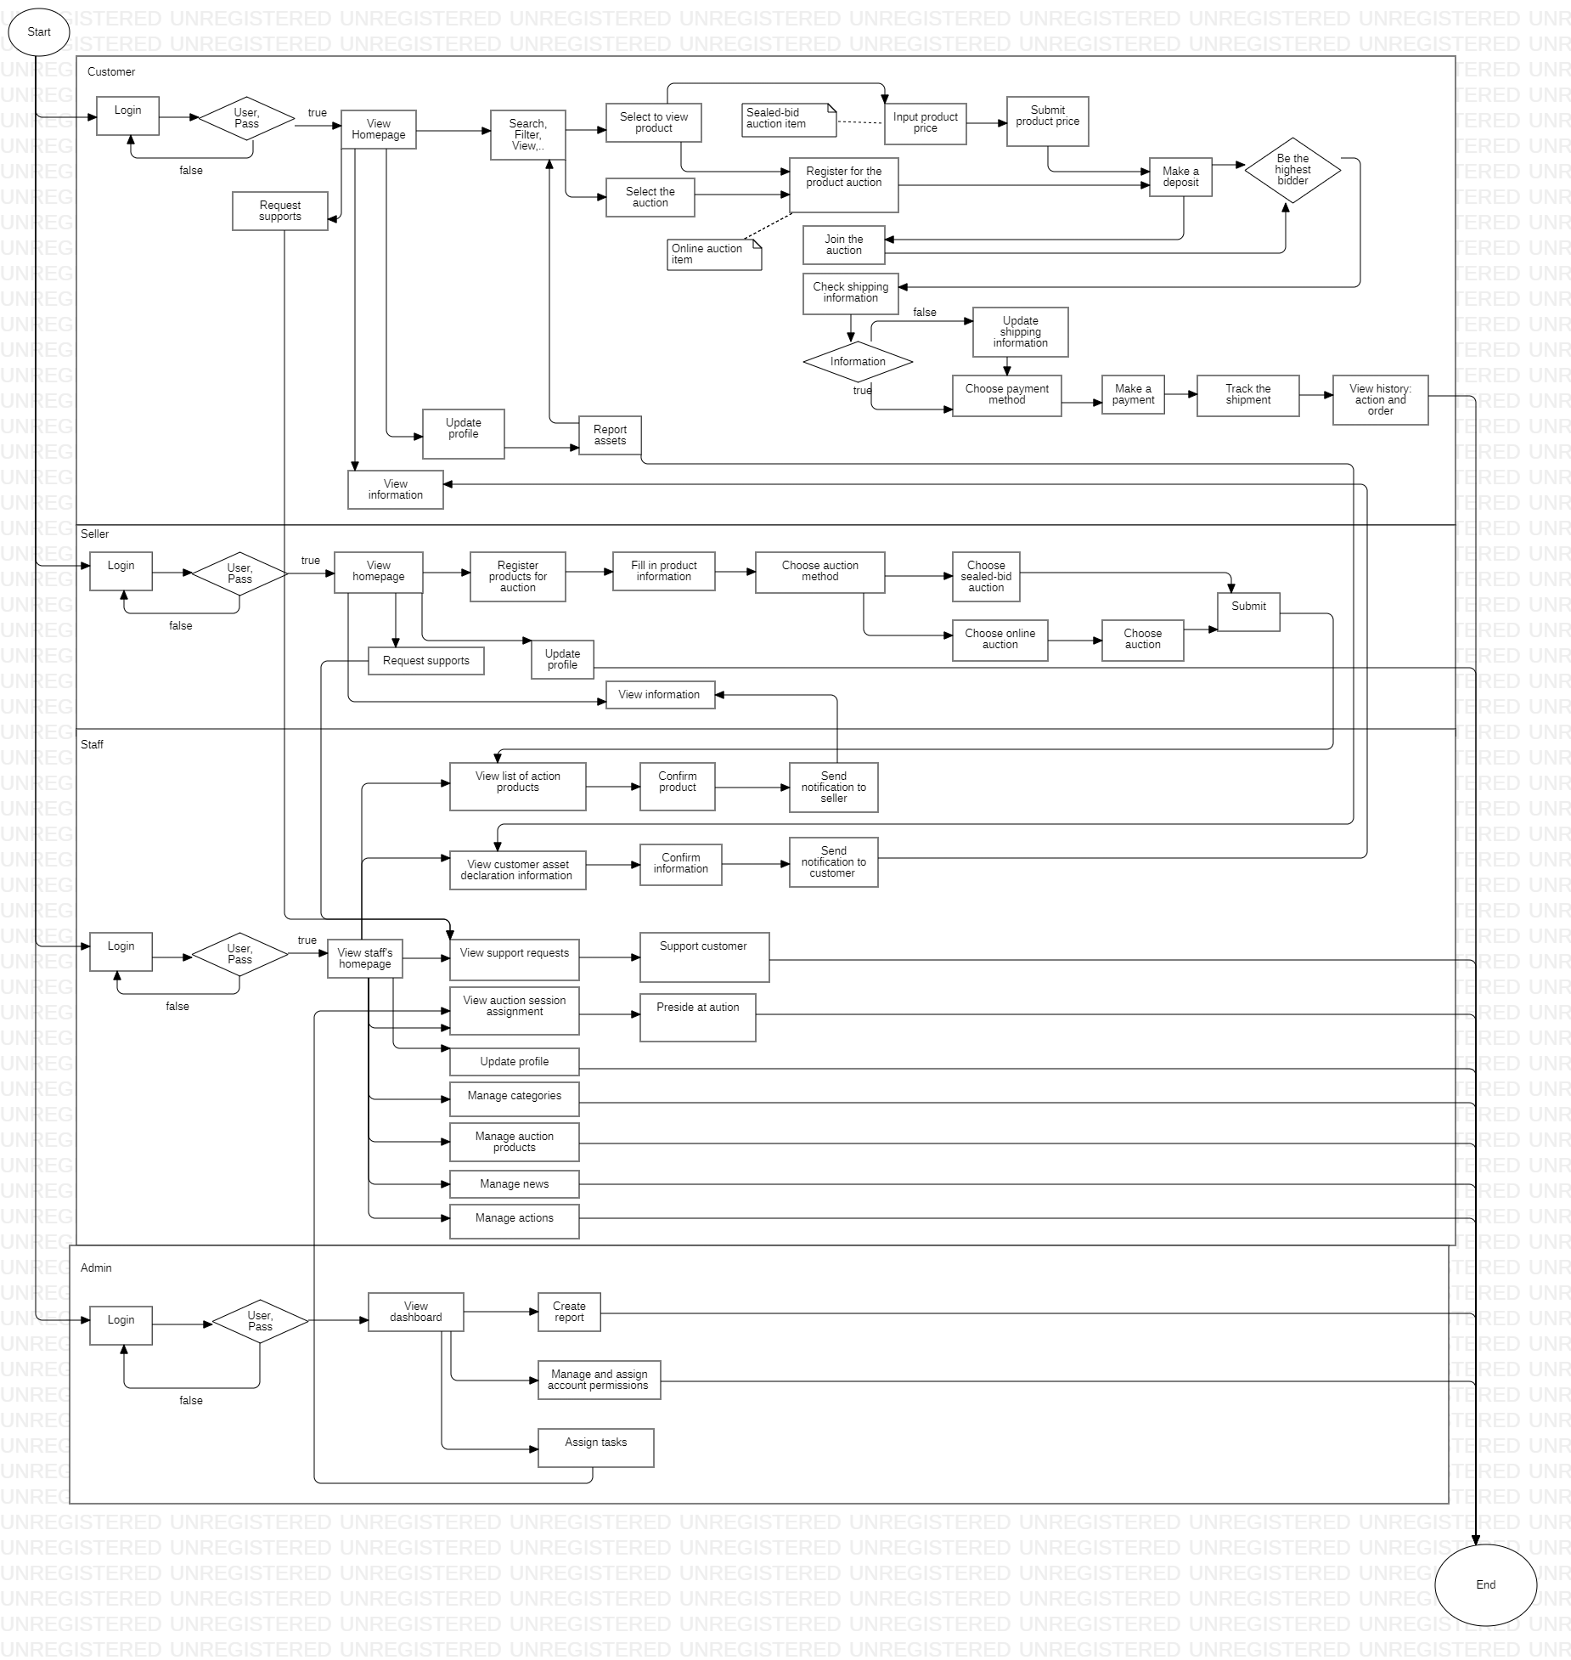

## **Use case diagram**

### **Actor**

|  |  |
| --- | --- |
| **Actor** | **Usecase** |
| Guest | • Register account  • Search – Filter information  • View products, auction sessions |
| Customer | • Login  • Search – Filter information  • Update and report assets  • Join auction  • Payment  • Track the shipment  • View history: action and order  • Request support |
| Seller | • Login  • Register for auction  • Register auction items  • Request support  • Update profile |
| Staff | • Login  • Preside at auction  • Appraise the assets of auction participants  • Appraise auction items  • Support customers  • Update profile  • Manage categories  • Manage auction products  • Manage news  • Manage actions |
| Admin | • Login  • Manage and assign account permissions  • View statistics  • Assign tasks |

### **Usecase Diagram**

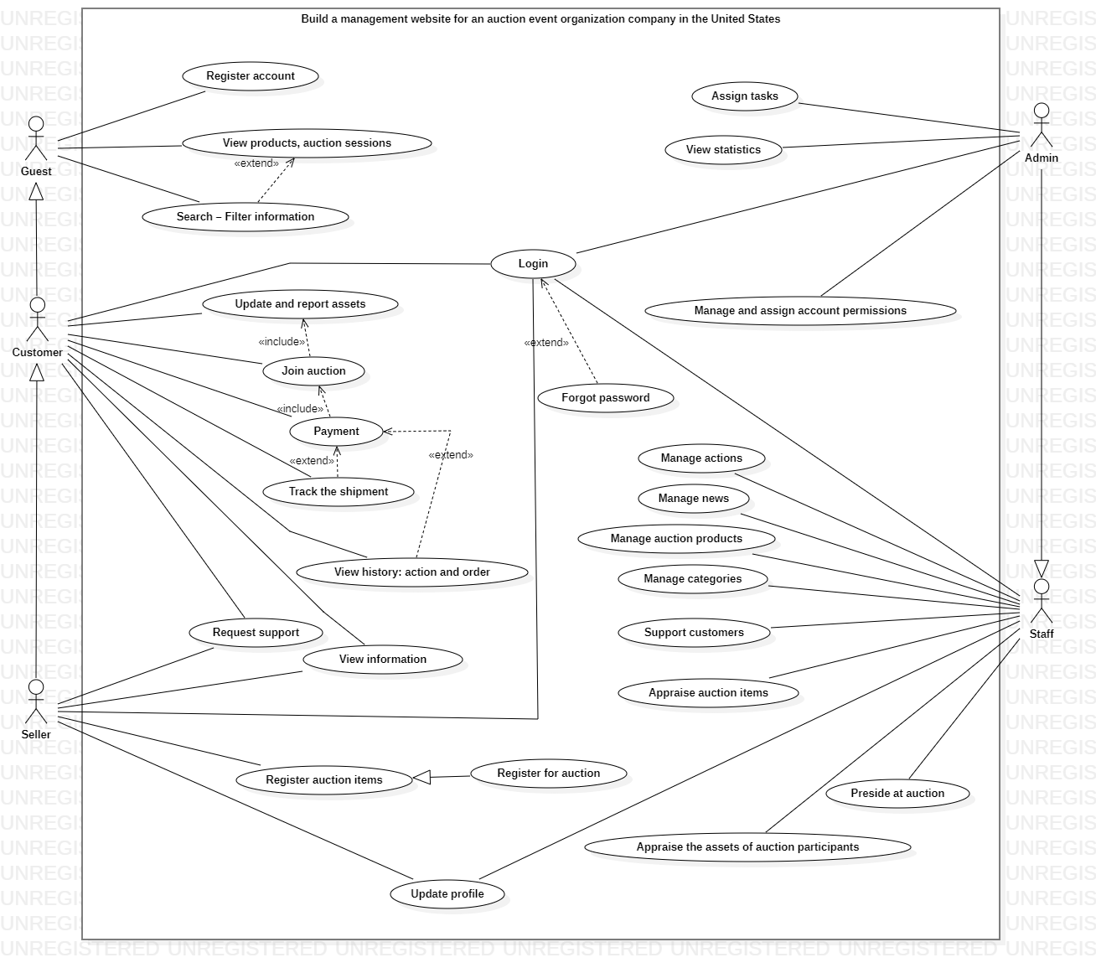

## **IV. Functionality**

### **Login**

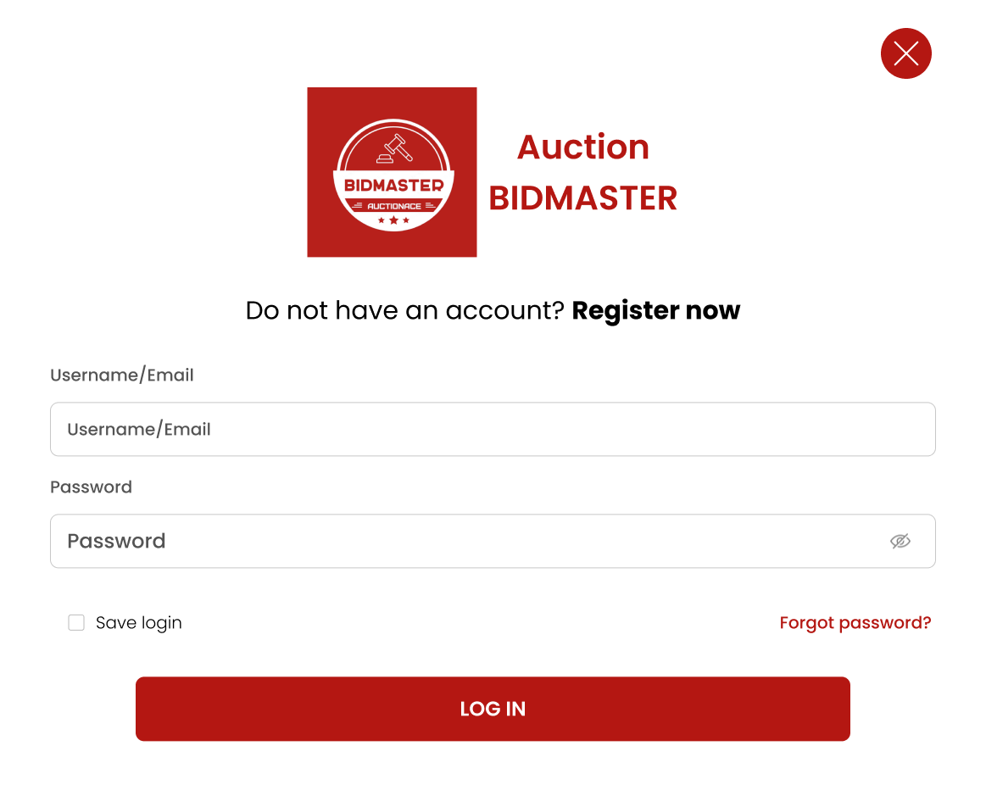

|  |  |
| --- | --- |
| **Function Diagram Name** | Login |
| **High-Level Requirements** | Allows users to log in to the system |
| **User** | All users/ seller |
| **Description** | Log into the system |
| **Activate** | Run the link web https://viettridao.com/... |
| **Prerequisites** | N/A |
| **Post-processing** | N/A |

**Screen Content**

|  |  |  |  |
| --- | --- | --- | --- |
| **Item** | **Type** | **Required?** | **Description** |
| Username/  Email | TextField – String (max) | Yes | Enter User Account |
| Password | TextField – String (max) | Yes | Enter user password. Data will be masked by “.” or “*” |
| Save login | Checkbox |  | When the "Remember me" box is checked, the login information will be retained in the two textboxes above after logout. By default, it is unchecked. |
| Forgot password? | Hyperlink |  | When "Forgot password?" is selected, the screen will redirect to the forgot password interface. |
| Log in | Button |  | Login system |

**Action**

|  |  |  |  |
| --- | --- | --- | --- |
| **Actor** | | **System** | |
| **Main Flow: Login system** | | | |
| 1 | Actor enters Username and Password. Clicks the Login button |  |  |
|  |  | 2 | Check if the Username and Password exist in the Account DB table. |
|  |  | 2.1 | If they exist and the user has a role of Customer or Seller, display the Home page - Customer. |
|  |  | 2.3 | If they do not exist, display the corresponding message. |

**Error Message**

|  |  |
| --- | --- |
| **Case** | **Notification Message** |
| Missing required field data. | {Field name} is required |
| Incorrect Username | The username is incorrect |
| Incorrect Password | The password is incorrect |

### **Home page**

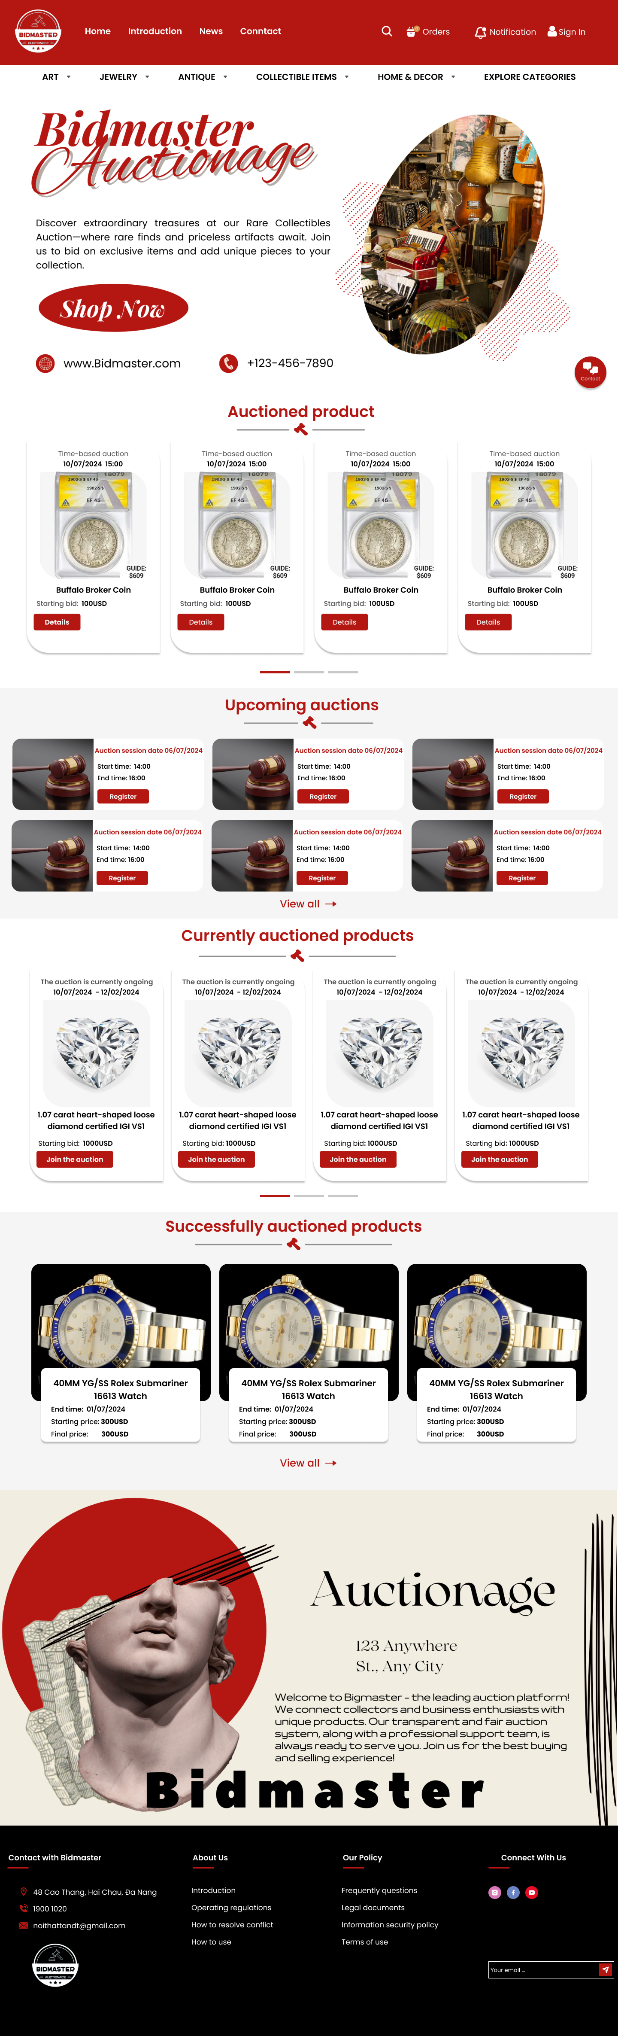

|  |  |
| --- | --- |
| **Function Diagram Name** | Display functions for Accounts with Customer/Seller permissions. |
| **High-Level Requirements** | Display system information. |
| **User** | Account with a role Customer/seller |
| **Description** | Home page allows users to search/view auction information available in the system. |
| **Activate** | NA |
| **Prerequisites** | Users must successfully log in to the system. |
| **Post-processing** |  |

**Screen Content**

|  |  |  |  |
| --- | --- | --- | --- |
| **Item** | **Type** | **Data** | **Description** |
| **Header > Main Menu** | | | |
| Main menu | Menu bar |  | Includes:   * Home * Introduction * News * Conntract |
| Search icon | Button |  | * Display search box for users to search * Format of the search box as described on the mockup * Search for information in the system based on input data (Auction, price, ...) * Proceed with the search |
| Notification icon | Button | The data is retrieved from the Notification and User (Customer/Seller) DB tables. | * Display notifications when clicked. * The format of the notifications as described in the mockup. * This button is only enabled when the user receives at least 1 notification. |
| Sign in icon | Button |  | * Display the login form – Log in to the system. * Refer to section IV.1 for more details. |
| **Home Page > Sub – Menu** | | | |
| Sub – menu | Combobox | The data is retrieved from the Category DB table. | Includes:   * ART * JEWELRY * ANTIQUE * COLLECTIBLE ITEMS * HOME & DECOR * EXPLORE CATEGORIES |
| **Home Page > Slider** | | | |
| Slider | Slider | The data is retrieved from the Media DB table. | * Display images of important information about the system. |
| **Home Page >**  **List of information displayed for users** | | | |
| List | List | The data is retrieved from the Auction + Asset DB table | List includes:   * Auctioned product: * Time * Image * Title * Starting bid * Buton Details * Upcoming auctions: * Time * Title * Button Register * Currently auctioned products * Time * Title * Starting bid * Button Join the auction * Successfully auctioned products * Time * Title * Starting price * Final price   The format of the list items as described in the mockup. |
| **Home Page >**  **Image** | | | |
| Image | Image |  | Display information about the website. |
| **Footer** | | | |
| Title |  |  | Includes:   * Contact with Bidmaster * About Us * Our Policy * Connect With Us * Logo * Text Emaill |

**Action**

|  |  |  |  |
| --- | --- | --- | --- |
| **Actor** | | **System** | |
| **Main Flow: Search project** | | | |
| 1 | On the Home Page – Customer/Seller, click the Search button and enter the data to search for. |  |  |
|  |  | 2.1 | Display the search box. |
|  |  | 2.2 | After loading the search data, navigate to the Search page. |
| 3 | On the Home Page – Customer/Seller, click the Notification button. |  |  |
|  |  | 3.1 | Display the list of user notifications. |
| 4 | On the Home Page – Customer/Seller, click the Sign In button. |  |  |
|  |  | 4 | Display the Login form. Refer to section IV.1 for the steps. |
| 5 | On the Home Page – Customer/Seller, click the comboboxes in the Sub-menu. |  |  |
|  |  | 5 | Display the list of options related to the combobox. |
| **Alternate Flow: Click Auctioned product** | | | |
| 6 | Click on the Details button or select any cell in the Auctioned Product section. |  |  |
|  |  | 7 | Navigate to the corresponding product detail page. |
| **Alternate Flow: Click Upcoming auctions** | | | |
| 8 | Nếu Click vào Upcoming auctions chọn vào 1 ô bất kì trong mục Upcoming auctions |  |  |
|  |  | 9 | Navigate to the corresponding auction detail page. |

### **Sign up page**

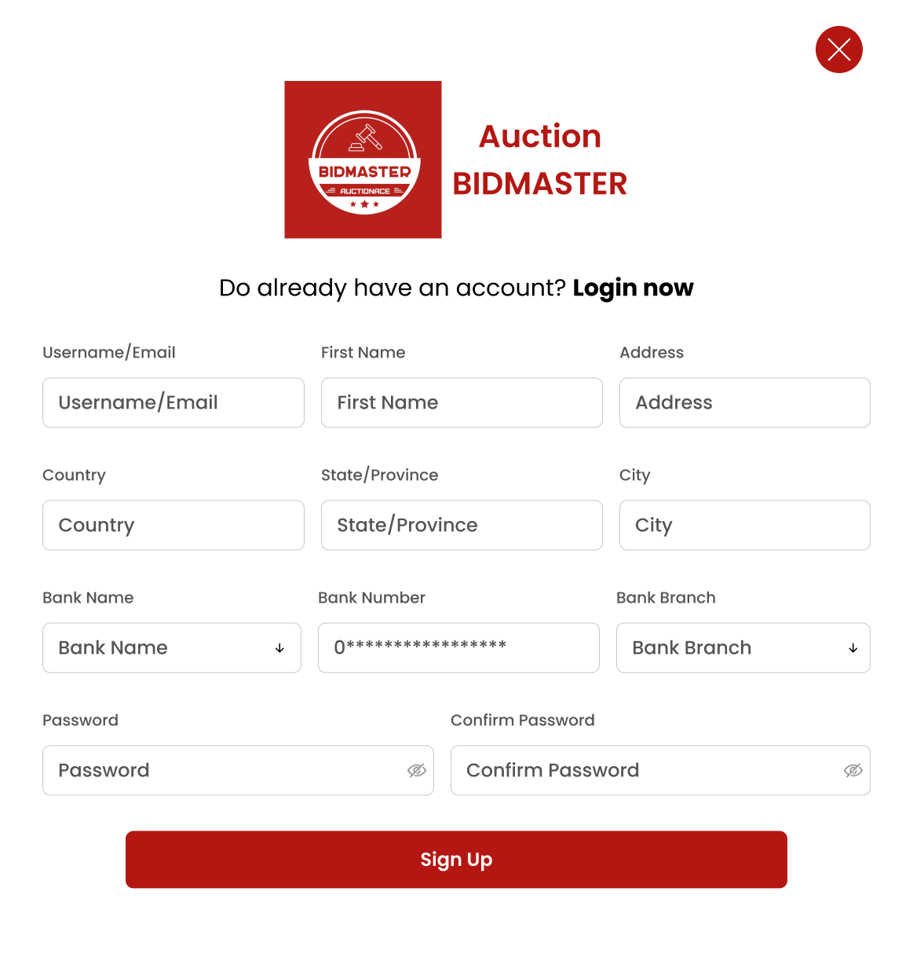

|  |  |
| --- | --- |
| **Function Diagram Name** | Create Account (Customer) |
| **High-Level Requirements** | Create new account information. The data will be inserted into the Account table. |
| **User** | The account has a role of ‘Customer’. |
| **Description** | This function diagram allows users to add new account information to the system. |
| **Activate** | NA |
| **Prerequisites** | Users must successfully log in to the system. |
| **Post-processing** |  |

**Screen Content**

|  |  |  |  |  |
| --- | --- | --- | --- | --- |
| **Item** | **Type** | **Data** | **Required?** | **Description** |
| Username/Email | TextField – String (max) | Default data is empty. Data will be stored in User.UserName. | Yes | The Username of the newly created account. |
| First Name | TextField – String (max) | Default data is empty. Data will be stored in User.Name. |  | The First Name of the newly created account. |
| Address | TextField – String (max) | Default data is empty. Data will be stored in Address. | Yes | The Address of the newly created account. |
| Country | Combobox | Default data is empty. Data will be stored in Country. | Yes | The Country of the newly created account. |
| State/ Province | Combobox | Default data is empty. Data will be stored in State. | Yes | The State of the newly created account. |
| City | Combobox | Default data is empty. Data will be stored in City. | Yes | The City of the newly created account. |
| Password | TextField – String (max) | Default data is empty. Data will be stored in User.Password. | Yes | The Password of the newly created account.  Data will be masked with * after losing focus. |
| Confirm Password | TextField – String (max) | Default data is empty. | Yes | Data will be masked with * after losing focus. |
| Sign Up | Button |  |  | Create a new account. |
| Login now | Button |  |  | Go back to the Login screen. |

**Action**

|  |  |  |  |
| --- | --- | --- | --- |
| **Actor** | | **System** | |
| **Main Flow: Create Account** | | | |
| 1 | On the Login page, click "Register now." |  |  |
|  |  | 2 | Display the "Create Account" popup. |
| 3 | Enter data into all fields and click the "Sign Up" button. |  |  |
|  |  | 4 | Check if the data is complete and correct. |
|  |  | 4.1 | If there are no errors:   * Add the account data to the Account table. * Display the message "Created successfully!". |
|  |  | 6.2 | If there are errors, display the corresponding message. |

**Error Message**

|  |  |
| --- | --- |
| **Case** | **Notification Message** |
| Missing required field data. | {Field name} is required |
| Account already exists in the system. | Account already existed in the system |
| Account contains spaces, Vietnamese characters, or special characters. | Account is invalid |
| Password contains spaces or Vietnamese characters. | Password is invalid |

### **Sealed auction product detail page**

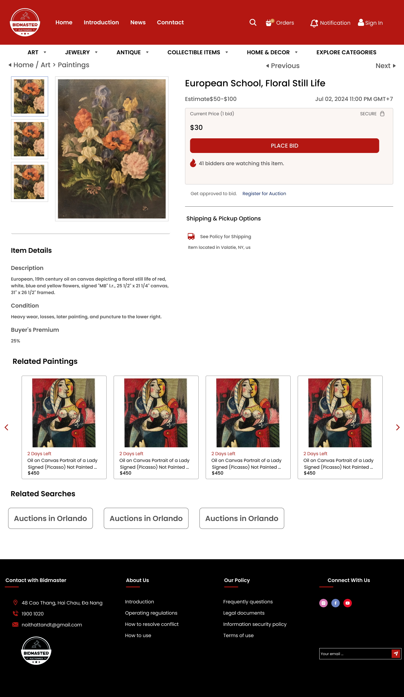

|  |  |
| --- | --- |
| **High-Level Requirements** | Display the product that the user wants to view. The data will be retrieved from the Asset table. |
| **User** | The account has a role of ‘Customer’. |
| **Description** | This function allows users to view details of the product they want to bid on and participate in the auction. |
| **Activate** | NA |
| **Prerequisites** | Users must successfully log in to the system. |
| **Post-processing** |  |

**Screen Content**

|  |  |  |  |
| --- | --- | --- | --- |
| **Item** | **Type** | **Data** | **Description** |
| Title | TextField | Data is retrieved from Asset.Name. | Display the product title |
| Image | Image | Data is retrieved from the MediaItem table. | Display the product image |
| Price | TextField | Data is retrieved from AuctionDetail. | Display the product sale price |
| Datetime | Datetime | Data is retrieved from Auction. | Display the product end date |
| StartingPrice | TextField | Data is retrieved from AuctionDetail. | Display the current bid price of the product |
| PLACE BID | Button |  | |  | | --- | |  |  |  | | --- | | Register to participate in the product auction | |
| Maximum Bid | TextField | Data is retrieved from AuctionDetail. | The product price bid by the user is newly created |
| Buyer's Premium | TextField | Data is retrieved from AuctionDetail. | Display the product tax |
| Subtotal | TextField |  | |  | | --- | |  |  |  | | --- | | Display the total amount the user needs to pay | |
| SEND | Button |  | Save the bid price information of the product |
| Item details | TextField | Data is retrieved from Asset. | Display product information |

**Action**

|  |  |  |  |
| --- | --- | --- | --- |
| **Actor** | | **System** | |
| **Main Flow: View Item details** | | | |
| 1 | Log into the system, select the sealed auction product to view details through the homepage or the product listing page. |  |  |
|  |  | 2 | Display the product information the user wants to view. |
| 3 | Log into the system, select the sealed auction product to view details through search. |  |  |
|  |  | 4 | Refer to section IV.6 for more details.  Display the product information the user wants to view |
| **Alternate Flow: Click button PLACE BID** | | | |
| 5 | Click the PLACE BID button on the detail page to start bidding. |  |  |
|  |  | 6 | The system displays the Place Bid form. |
| 7 | Enter the bid amount -> SEND. |  |  |
|  |  | 8 | The system saves the bid amount to the database and returns a code to the user. |
| 9 | User enters the code -> SEND. |  |  |
|  |  | 10 | Verify if the code is correct – save the auction information. |

**Error Message**

|  |  |
| --- | --- |
| **Case** | **Notification Message** |
| The account cannot bid higher than the initial price | Please enter a higher price |

### **The online auction detail page**

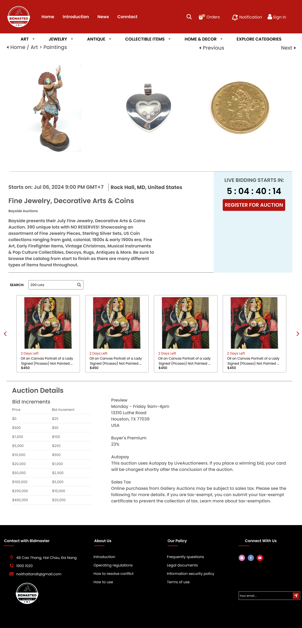

|  |  |
| --- | --- |
| **Function Diagram Name** | View online auction details – Participate in online auction |
| **High-Level Requirements** | Display the online auction that the user wants to view. The data will be retrieved from the Auction table. |
| **User** | The account has a role of ‘Customer’. |
| **Description** | This function allows users to view online auction details and participate in the auction. |
| **Activate** | NA |
| **Prerequisites** | Users must successfully log in to the system. |
| **Post-processing** |  |

**Screen Content**

|  |  |  |  |
| --- | --- | --- | --- |
| **Item** | **Type** | **Data** | **Description** |
| Datetime | Datetime | Data is retrieved from Auction. | Display the start date of the auction. |
| Title | TextField | Data is retrieved from Auction. | Display the name of the auction. |
| Image | Image | Data is retrieved from the MediaItem table. | Display the product image. |
| Description | TextField | Data is retrieved from Auction. | Display the description of the auction. |
| Datetime | Datetime | Data is retrieved from Auction. | Display the start date of the auction. |
| REGISTER FOR AUCTION | Button |  | Register to participate in the auction. |
| Buyer's Premium | TextField | Data is retrieved from AuctionDetail. | Display the tax on the product. |
| Subtotal | TextField |  | Display the total amount the user needs to pay. |
| SEND | Button |  | Save the bid price information for the auctioned product. |
| Auction Details | TextField | Data is retrieved from AuctionDetail. | Display detailed information about the auction. |

**Action**

|  |  |  |  |
| --- | --- | --- | --- |
| **Actor** | | **System** | |
| **Main Flow: View Item details** | | | |
| 1 | Log into the system, select the online auction to view details through the homepage or the product listing page. |  |  |
|  |  | 2 | Display the online auction information the user wants to view. |
| 3 | Log into the system, select the online auction to view details through search. |  |  |
|  |  | 4 | Refer to section IV.6 for more details.  Display the auction information the user wants to view. |
| **Alternate Flow: Click button PLACE BID** | | | |
| 5 | Click the REGISTER FOR AUCTION button on the detail page to start registering for the auction. |  |  |
|  |  | 6 | The system displays the Place Bid form. |
| 7 | Click -> SEND |  |  |
|  |  | 8 | The system saves the bid deposit to the database and returns a code to the user. |
| 9 | The user enters the code -> SEND. |  |  |
|  |  | 10 | Verify if the code is correct – save the auction information. |

### **Search page**

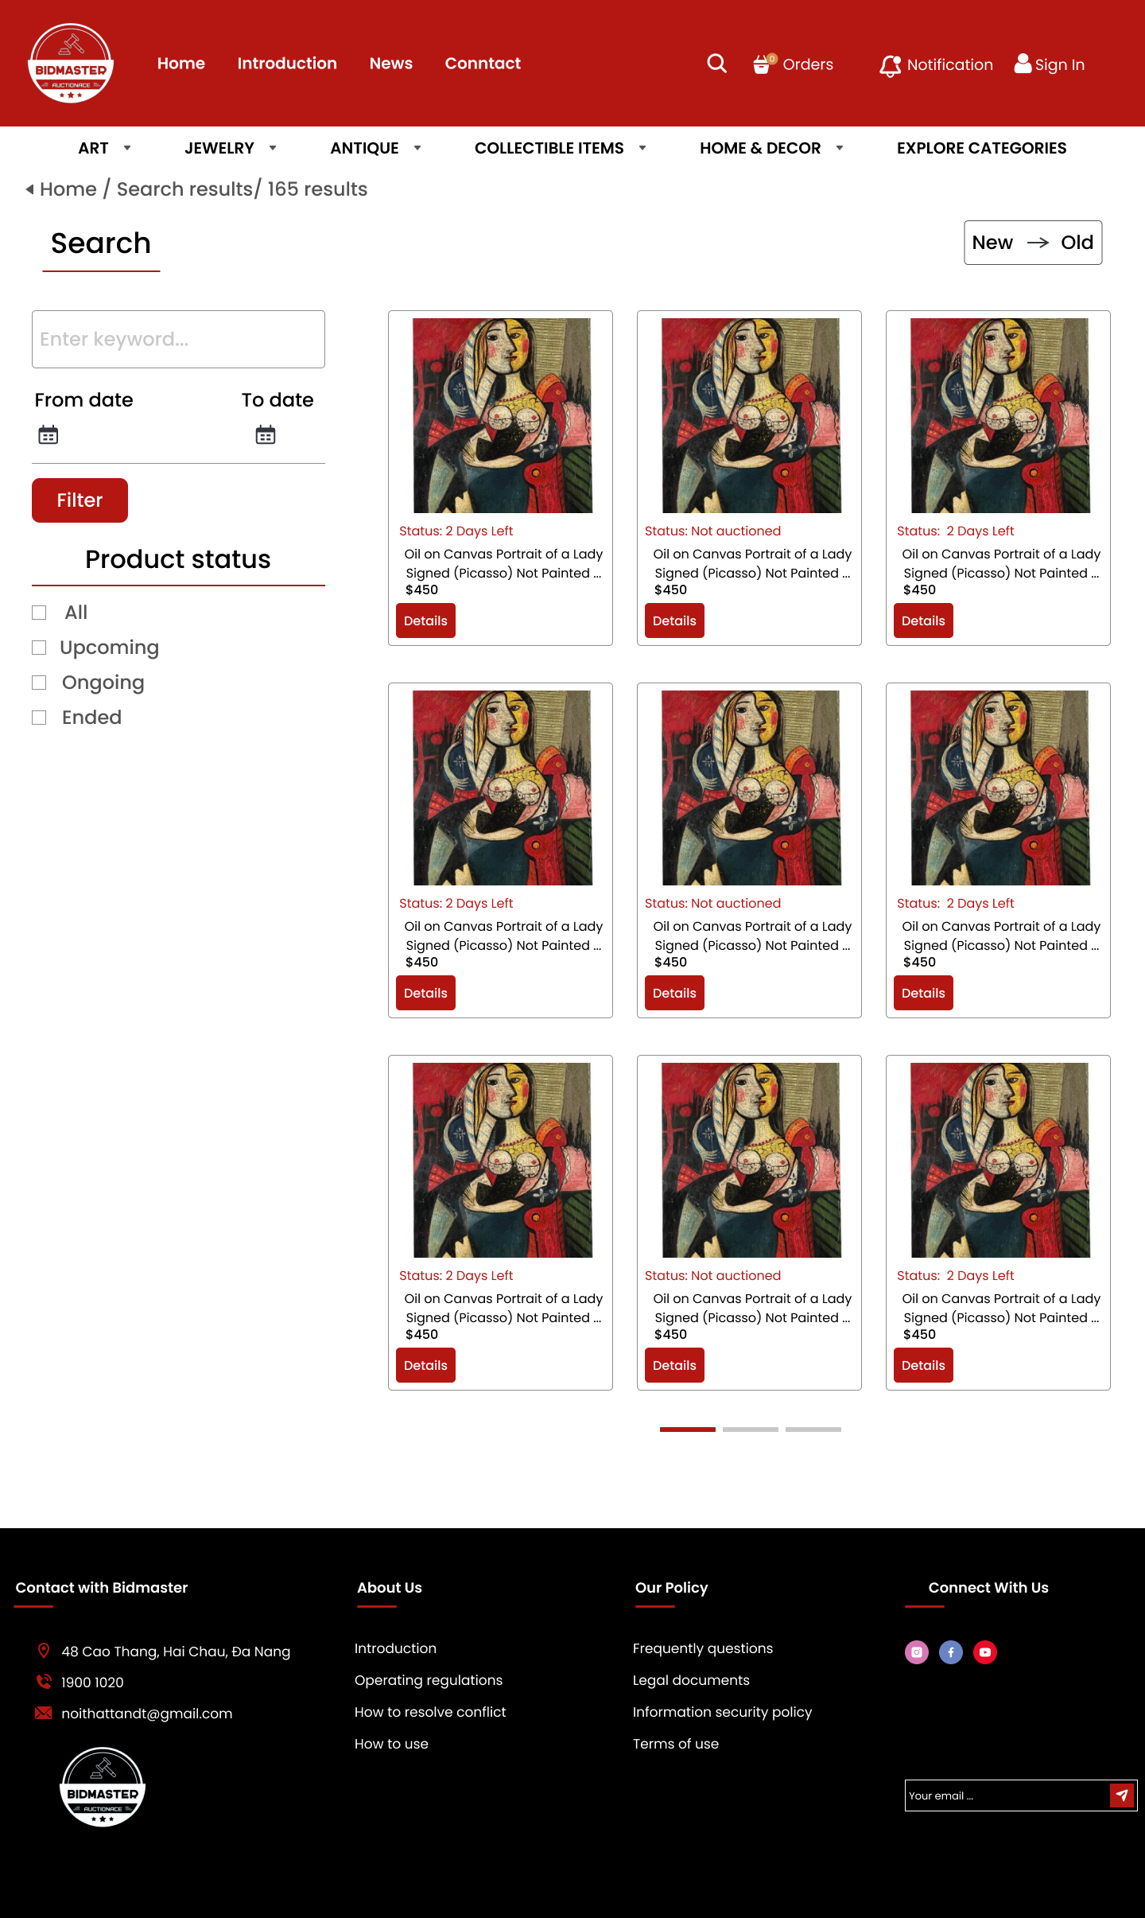

|  |  |
| --- | --- |
| **Function Diagram Name** | Search for auction and product information. |
| **High-Level Requirements** | Retrieve the auctions and products that the user wants to view. |
| **User** | The account has a role of ‘Customer’. |
| **Description** | This function allows users to search for the information requested by customers. |
| **Activate** | NA |
| **Prerequisites** | Users must successfully log in to the system. |
| **Post-processing** |  |

**Screen Content**

|  |  |  |  |
| --- | --- | --- | --- |
| **Item** | **Type** | **Data** | **Description** |
| New -> Old | Button |  | Filter products by New -> Old or Old -> New. |
| Texbox | TextBox – String (100) |  | Enter the information to search in the textbox. |
| From date | Date Picker |  | Select the start time. |
| To date | Date Picker |  | Select the end time. |
| Filter | Button |  | Search for information after entering and selecting. |
| Status | Checkbox | Asset | Includes the following values:   * All * Upcoming * Ongoing * Ended |
| List | List | Data is retrieved from Auction+ Asset | Includes:   * Status * Title * Price * Details Button   The format of the list items as described in the mockup. |

**Action**

|  |  |  |  |
| --- | --- | --- | --- |
| **Actor** | | **System** | |
| **Main Flow: Search** | | | |
| 1 | Log into the system, click the search button -> Enter the search information. |  |  |
|  |  | 2.1 | Display the search box. |
|  |  | 2.2 | Search for content based on what the user has entered. |
|  |  | 2.3 | Display the information found by the user on the Search page. |
| **Alternate Flow** | | | |
| 3 | Click on New -> Old. |  |  |
|  |  | 4 | The status changes to Old -> New. |
| 5 | Enter information into the textbox. |  |  |
| 6 | Select the “From date” and “To date.” |  |  |
| 7 | Click button Filter |  |  |
|  |  | 8.1 | The system displays a date picker for the user to select. |
|  |  | 8.2 | The system filters according to the list the user has filtered. |
| 9 | Click one of the four checkboxes:   * Status * Title * Price * Details Button |  |  |
|  |  | 10 | The system filters based on the checkboxes the user has selected. |
| 11 | Click the “Detail” button in the search results list. |  |  |
|  |  | 11 | The system navigates to the corresponding page. |

### **Cart page**

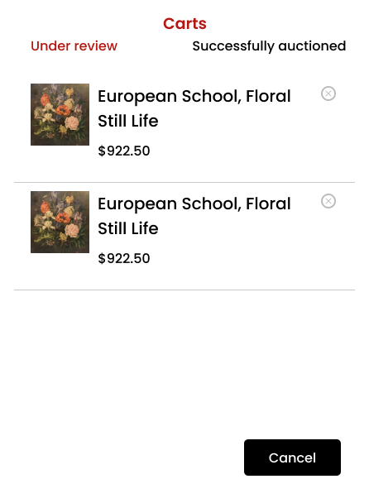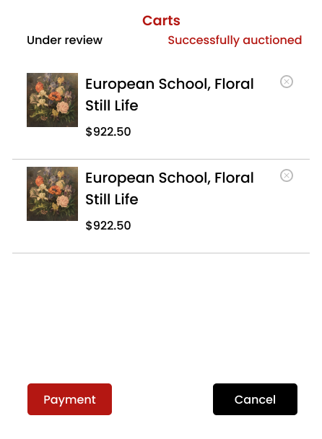

|  |  |
| --- | --- |
| **High-Level Requirements** | View all orders that have been placed and won. |
| **User** | The account has a role of ‘Customer’. |
| **Description** | This function allows users to view orders that have been completed previously. |
| **Activate** | NA |
| **Prerequisites** | Users must participate in the product auction. |
| **Post-processing** |  |

**Screen Content**

|  |  |  |  |
| --- | --- | --- | --- |
| **Item** | **Type** | **Data** | **Description** |
| Titile | TextFile | Data is retrieved from Asset.Name | Display the product name |
| Price | TextFile | Data is retrieved from AuctionDetails | Display the product price after deposit and winning the bid. |
| Icon | Button |  | Remove the product displayed in Carts. |
| Cancel | Button |  | Exit the Carts page. |
| Payment | Button |  | Proceed to checkout for the product. |

**Action**

|  |  |  |  |
| --- | --- | --- | --- |
| **Actor** | | **System** | |
| **Main Flow: View Carts** | | | |
| 1 | From the homepage, select the cart icon. |  |  |
|  |  | 2.1 | Display the cart form. |
| **Alternate Flow: Click Under review** | | | |
| 3 | Select the product you want to view. |  |  |
|  |  | 4 | The system navigates to the corresponding page. |
| 5 | Click icon icon “x” |  |  |
|  |  | 6 | Remove the product from the cart. |
| 7 | Click button Cancel |  |  |
|  |  | 8 | Exit the cart and return to the homepage. |
| **Alternate Flow: Click Successfully auctioned** | | | |
| 9 | Select the product you want to view. |  |  |
|  |  | 10 | The system navigates to the corresponding page. |
| 11 | Chọn icon icon “x” |  |  |
|  |  | 12 | Remove the product from the cart. |
| 13 | Click button Cancel |  |  |
|  |  | 8 | Exit the cart and return to the homepage. |
| 14 | Click button “Payment” |  |  |
|  |  | 15 | The system navigates to the checkout page |

### **Payment page**

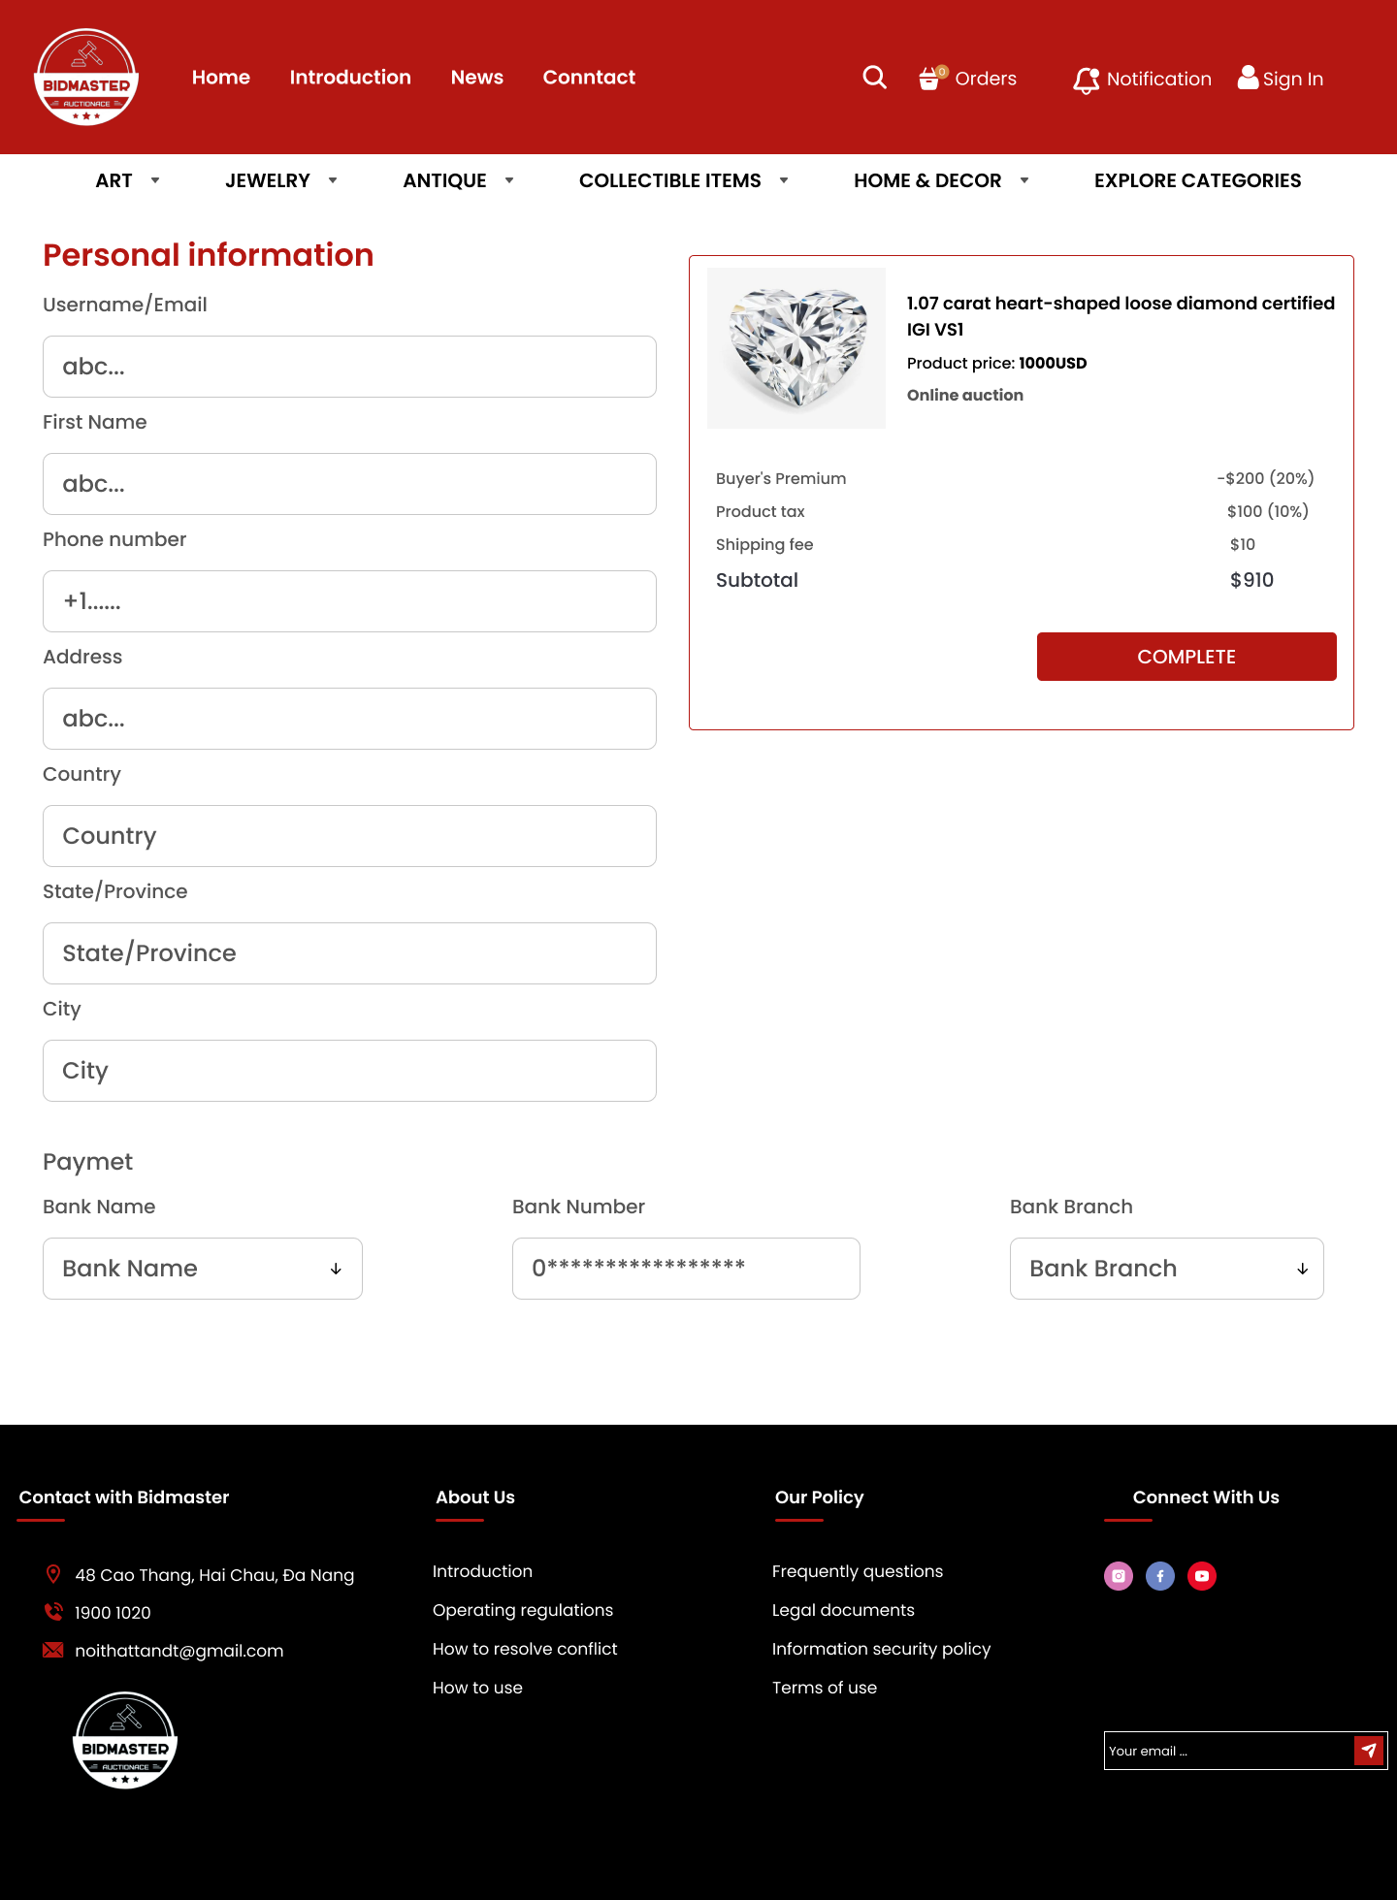

|  |  |
| --- | --- |
| **Function Diagram Name** | Payment |
| **High-Level Requirements** | Successfully pay for the order that has been won. |
| **User** | The account has a role of ‘Customer’. |
| **Description** | This function allows users to proceed with the payment for the order they have won. |
| **Activate** | NA |
| **Prerequisites** | The user must have won the bid for the product. |
| **Post-processing** |  |

**Screen Content**

|  |  |  |  |
| --- | --- | --- | --- |
| **Item** | **Type** | **Data** | **Description** |
| Textbox | Textbox | Data is retrieved from Asset, AuctionDetails | Includes:   * Username/Email * First Name * Phone number * Address * Country * State/Province * City * Bank Number |
| Combobox | Combobox |  | Includes:   * Bank Name * Bank Branch   Values are retrieved from the API. |
| Title | TextFile | Data is retrieved from Asset.Name | Display the product name. |
| Text | TextFile | Data is retrieved from Asset, AuctionDetails | Includes:   * Product price * Auction * Buyer's Premium * Product tax * Shipping fee |
| COMPLETE | Button |  | Proceed to checkout for the product. |

**Action**

|  |  |  |  |
| --- | --- | --- | --- |
| **Actor** | | **System** | |
| **Main Flow: View Carts** | | | |
| 1 | From the cart page, select the "Payment" button. |  |  |
|  |  | 2 | The system navigates to the payment page. |
| 3 | Check the shipping information. |  |  |
| 4 | Click button “COMPLETE” |  |  |
|  |  | 5.1 | The system confirms successful payment and returns to the homepage. |
|  |  | 5.2 | The system confirms unsuccessful payment and returns a message. |

**Error Message**

|  |  |
| --- | --- |
| **Case** | **Notification Message** |
| The payment for the order was unsuccessful due to incorrect information, bank details, balance, etc. | Please review the order information. |

### **Personal information page**

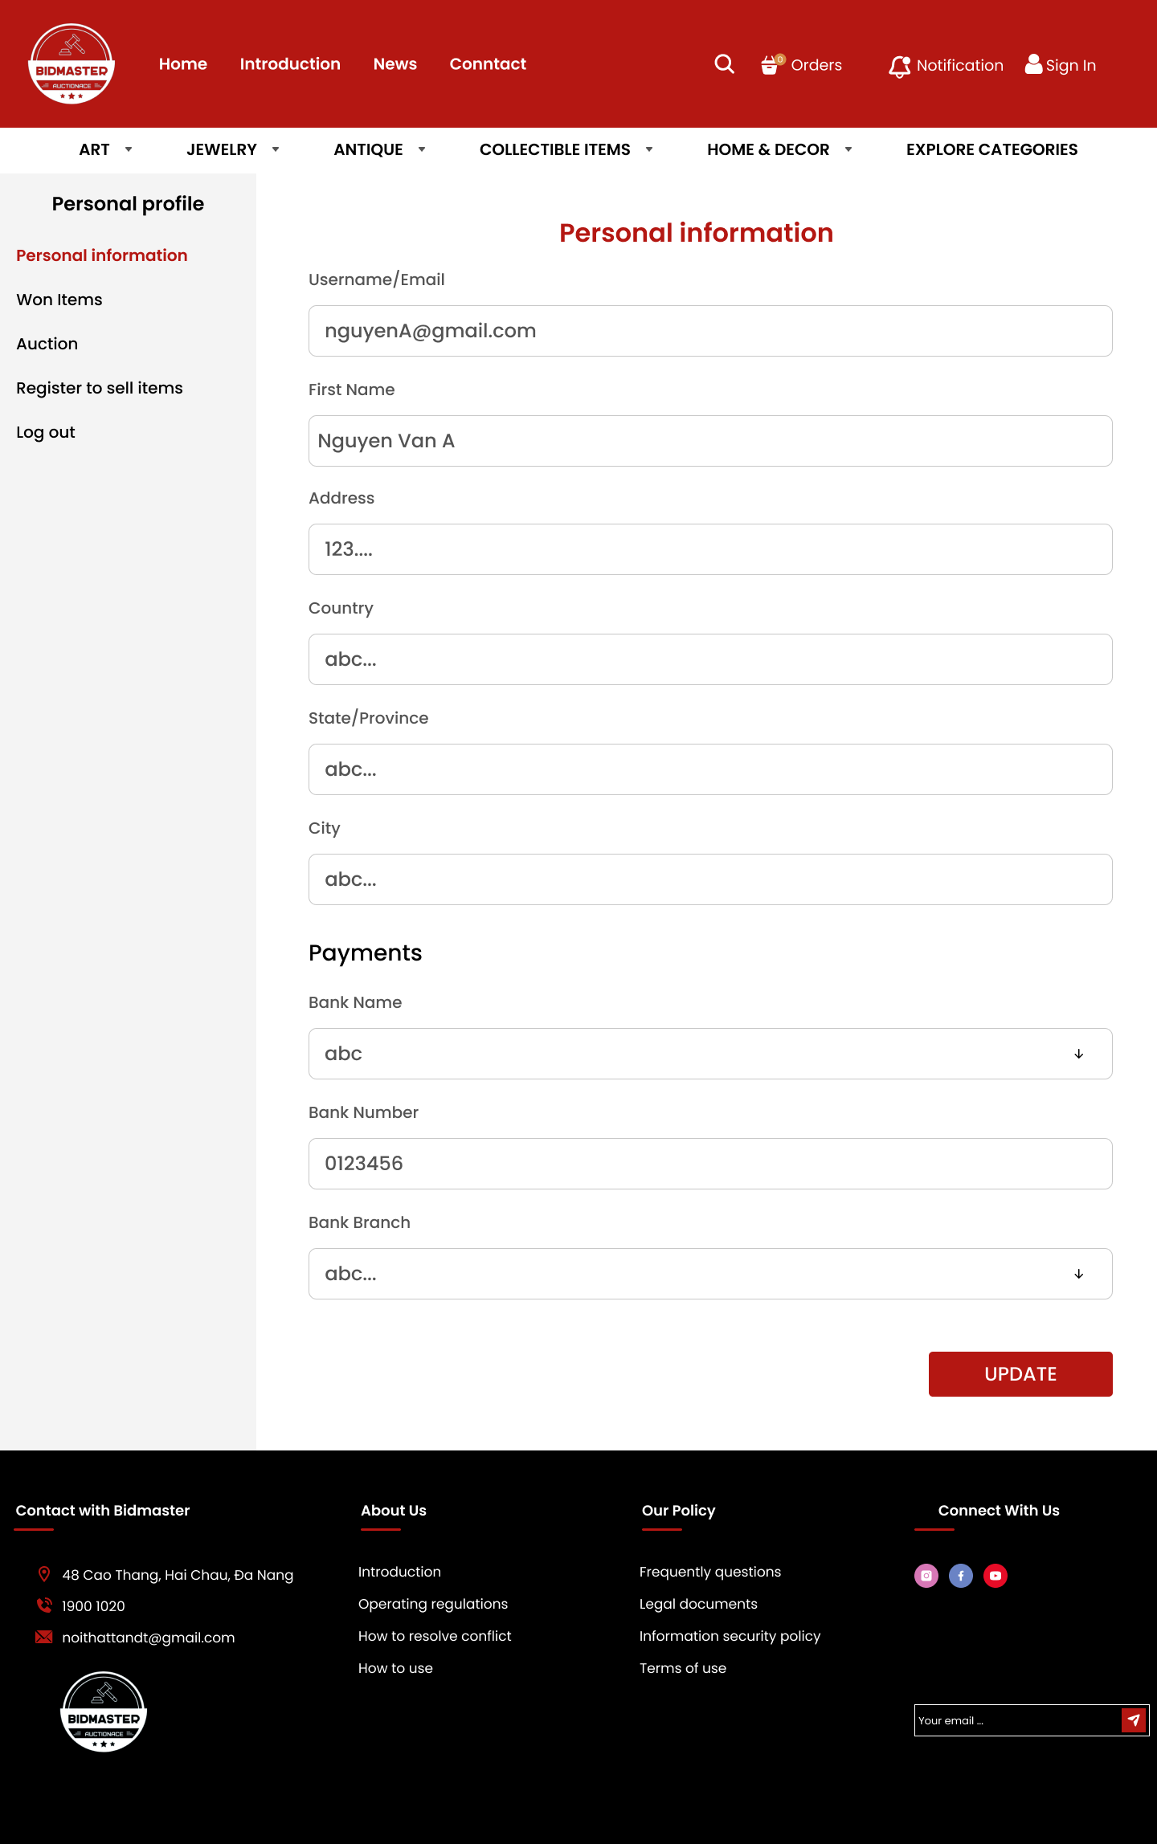

|  |  |
| --- | --- |
| **Function Diagram Name** | Update customer information. |
| **High-Level Requirements** | Update all information that the customer has registered. |
| **User** | The account has a role of ‘Customer’. |
| **Description** | This function allows users to update the information they desire. |
| **Activate** | NA |
| **Prerequisites** | The user has successfully registered an account. |
| **Post-processing** |  |

**Screen Content**

|  |  |  |  |
| --- | --- | --- | --- |
| **Item** | **Type** | **Data** | **Description** |
| Textbox | Textbox | Data is retrieved from User | Includes:   * Username/Email * First Name * Address * Number * Country * State/Province * City * Bank Number |
| Combobox | Combobox |  | Includes:   * Bank Name * Bank Branch   Values are retrieved from the API. |
| UPDATE | Button |  | Update account information. |

**Action**

|  |  |  |  |
| --- | --- | --- | --- |
| **Actor** | | **System** | |
| **Main Flow: View Carts** | | | |
| 1 | On the homepage, click the user button. |  |  |
|  |  | 2 | Check if the data has changed and is correct. |
| 3 | Enter data into the text field to be edited and click the UPDATE button. |  |  |
| 4 |  | 4 | Check if the data has changed and is correct. |
|  |  | 4.1 | If no errors occur:   * The selected record is updated in the User table.   Display the message “Updated successfully!”. |
|  |  | 4.2 | If there are errors, display the corresponding message. |

**Error Message**

|  |  |
| --- | --- |
| **Case** | **Notification Message** |
| Missing required field data. | “{Field name} is required” |

### **Won page**

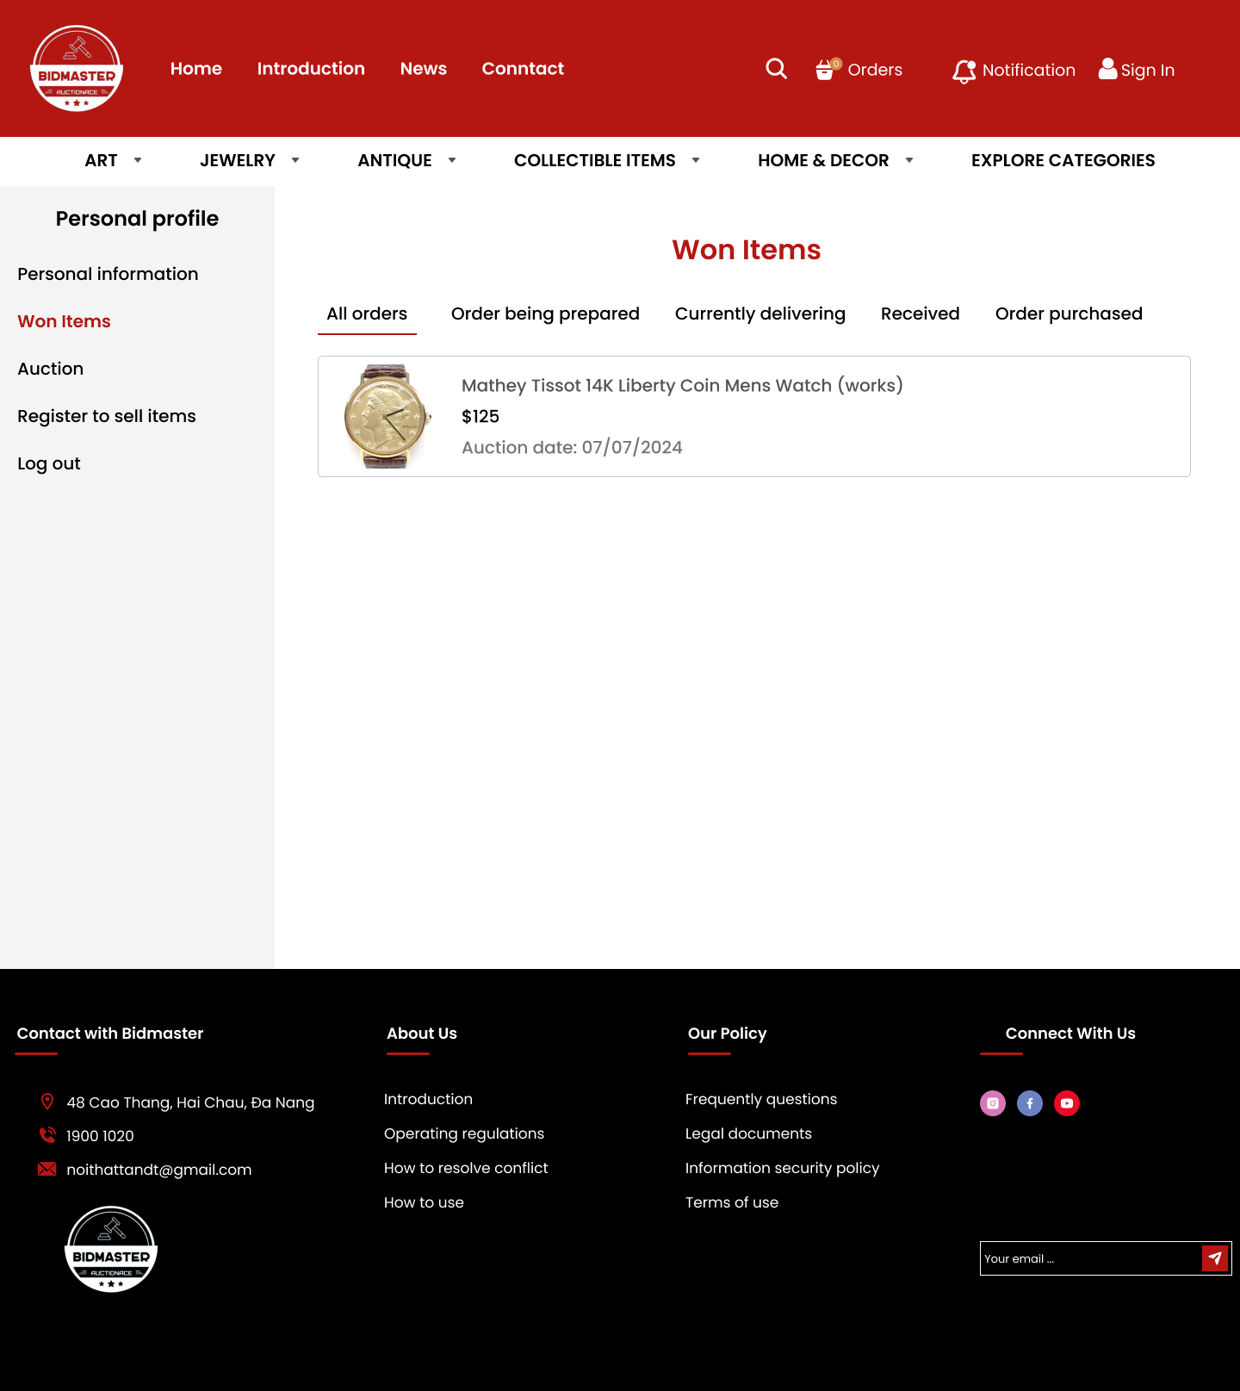

|  |  |
| --- | --- |
| **Function Diagram Name** | View the auctioned products. |
| **High-Level Requirements** | View all successfully auctioned products and track the order. |
| **User** | The account has a role of ‘Customer’. |
| **Description** | This function allows users to view the products they have auctioned and the preparation process of their order. |
| **Activate** | NA |
| **Prerequisites** | The user successfully auctions the product. |
| **Post-processing** |  |

**Screen Content**

|  |  |  |  |
| --- | --- | --- | --- |
| **Item** | **Type** | **Data** | **Description** |
| Image | Image | Data is retrieved from Media | Display the image the product |
| Title | TextFile | Data is retrieved from Asset.Name | Display the title of the product. |
| Price | TextFile | Data is retrieved from AuctionDetails | Display the price of the product. |
| DateTime | DateTime | Data is retrieved from AuctionDetails | Displays the date and time the auction was successful |

**Action**

|  |  |  |  |
| --- | --- | --- | --- |
| **Actor** | | **System** | |
| **Main Flow: View Carts** | | | |
| 1 | On the homepage, click the user button -> click Won Items. |  |  |
|  |  | 2 | Navigate to the Won Items page. |
| 3 | Click on the successfully auctioned product to view details. |  |  |
|  |  | 4 | The system navigates to the corresponding page. |
| 5 | Click on the statuses to track the order:   * All orders * Order being prepared * Currently delivering * Received * Order purchased |  |  |
|  |  | 6 | The system navigates to the selected status. |

### **Auction page**

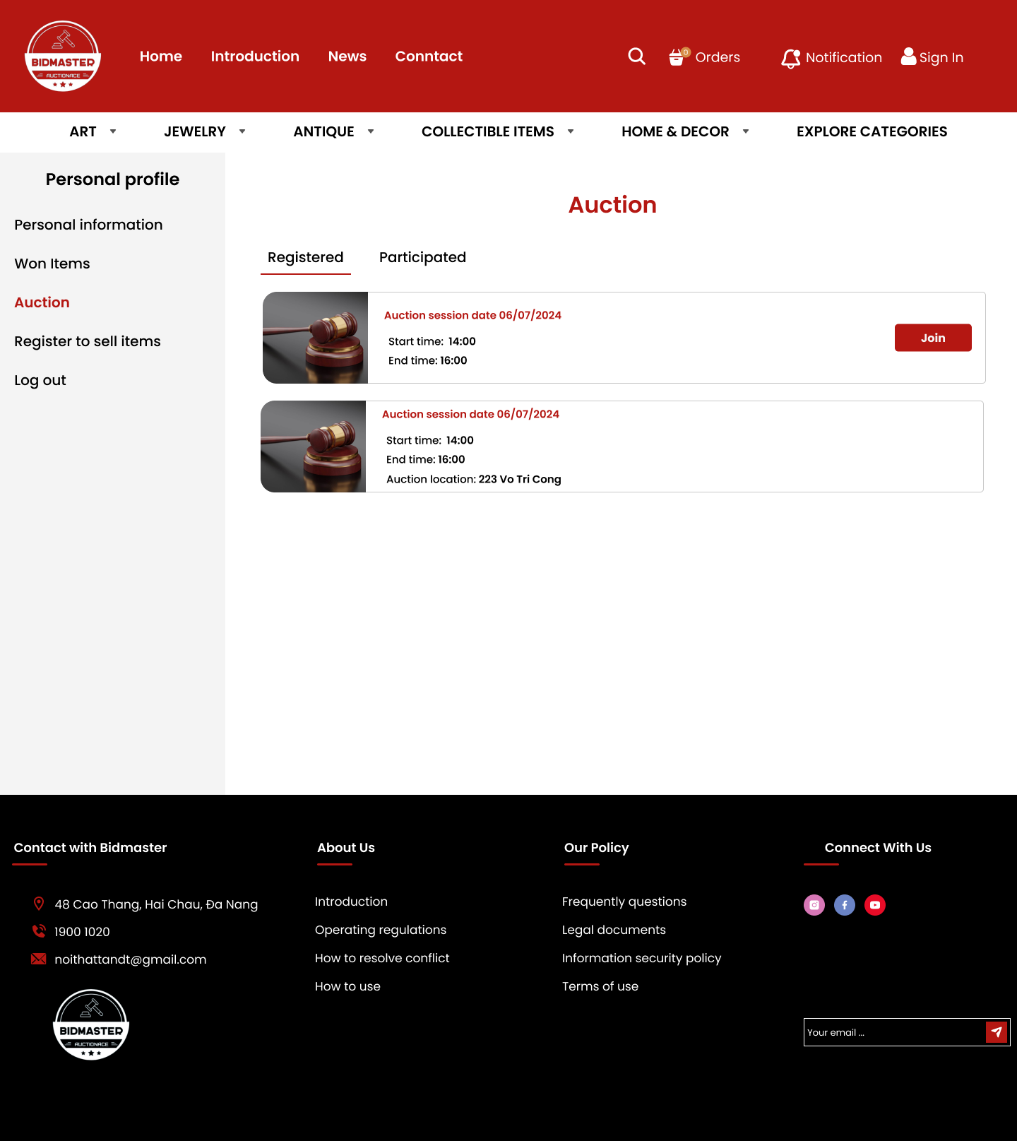

|  |  |
| --- | --- |
| **Function Diagram Name** | View the auctions that have been registered for and participated in. |
| **High-Level Requirements** | View all auctions that have been registered for and participated in. |
| **User** | The account has a role of ‘Customer’. |
| **Description** | This function allows users to view the auctions they have previously participated in and are currently registered for. |
| **Activate** | NA |
| **Prerequisites** | The user successfully registers for and participates in the auction. |
| **Post-processing** |  |

**Screen Content**

|  |  |  |  |
| --- | --- | --- | --- |
| **Item** | **Type** | **Data** | **Description** |
| Title | TextFile | Data is retrieved from Auction | Display the title of the auction. |
| Start time | DateTime | Data is retrieved from Auction | Display the start date and time. |
| End time | DateTime | Data is retrieved from Auction | Display the end date and time. |
| Join | Button |  | Participate in the auction. |

**Action**

|  |  |  |  |
| --- | --- | --- | --- |
| **Actor** | | **System** | |
| **Main Flow: View Carts** | | | |
| 1 | On the homepage, click the user button -> click Auction. |  |  |
|  |  | 2 | Navigate to the Auction page. |
| 3 | Click on the registered auction to view details. |  |  |
|  |  | 4 | The system navigates to the corresponding page. |
| 5 | Click button “Join” |  |  |
|  |  | 6 | The system navigates to the Room page. |

### **Room page**

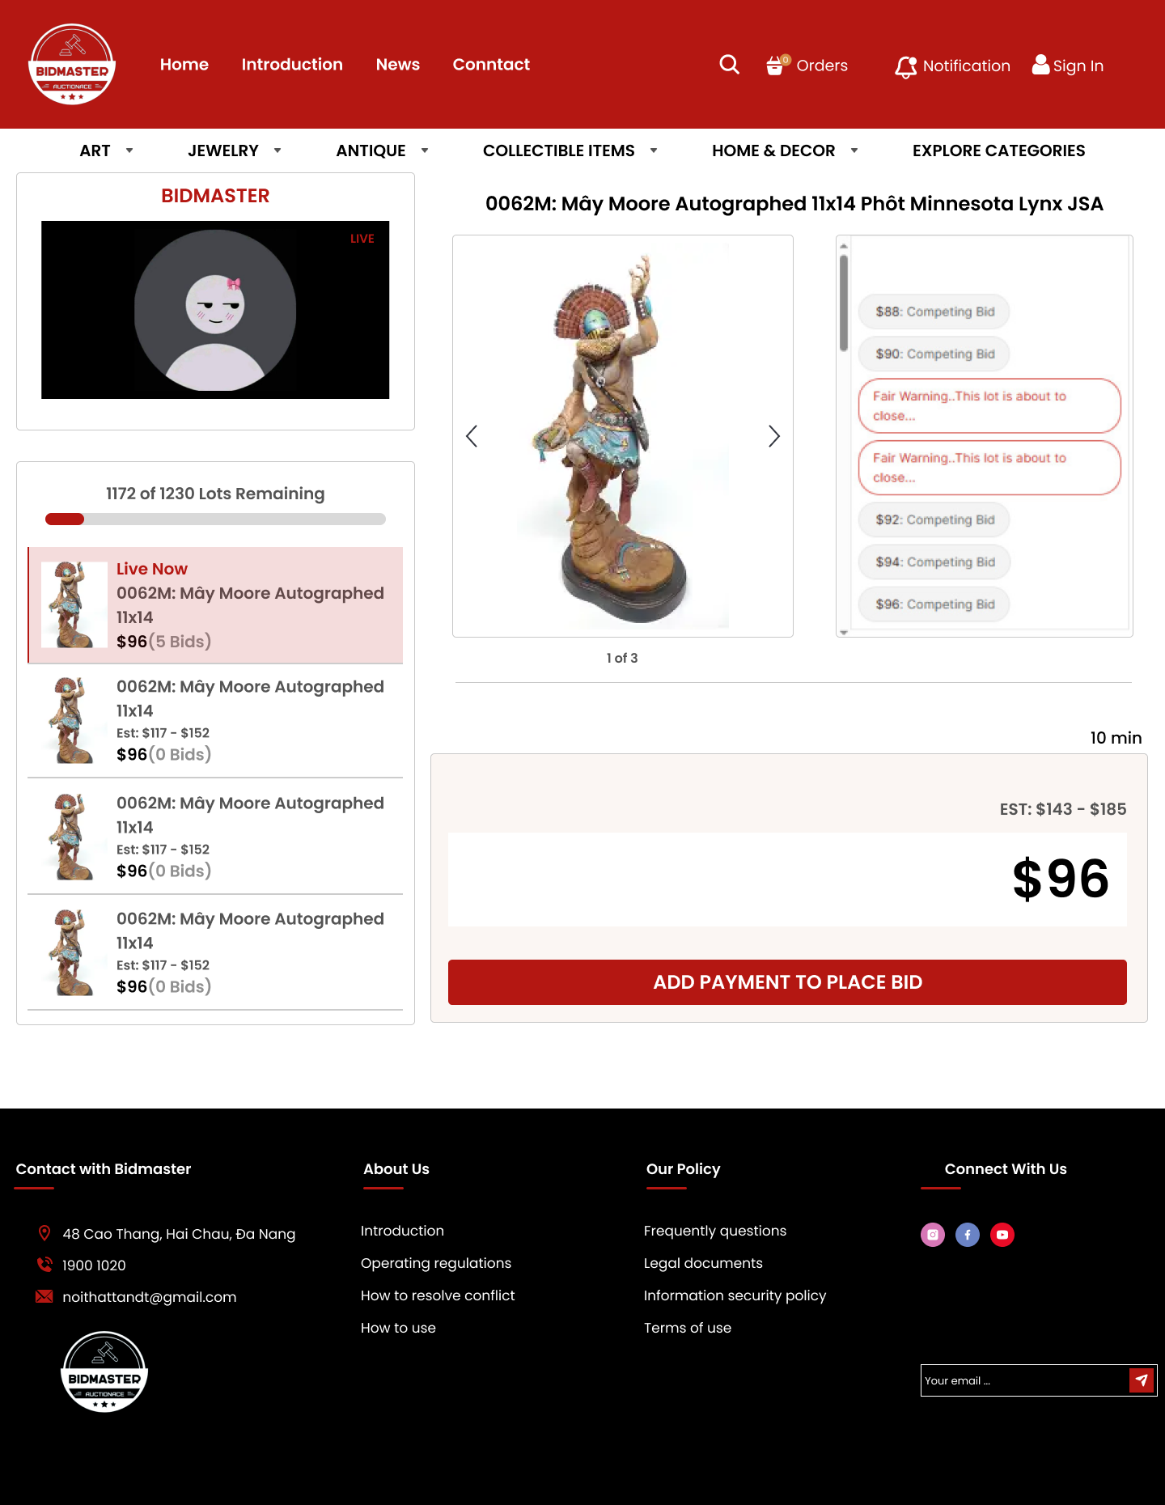

|  |  |
| --- | --- |
| **Function Diagram Name** | Participate in the online auction. |
| **High-Level Requirements** | Customers can participate in the auction and bid on products. |
| **User** | The account has a role of ‘Customer’. |
| **Description** | This function allows users to directly participate in the ongoing auction. |
| **Activate** | NA |
| **Prerequisites** | The user has successfully logged into the account. |
| **Post-processing** |  |

**Screen Content**

|  |  |  |  |
| --- | --- | --- | --- |
| **Item** | **Type** | **Data** | **Description** |
| Image | Image | Data is retrieved from Media | Display the image the product |
| Title | TextFile | Data is retrieved from Asset.Name | Display the name of the product. |
| Current Price | TextFile | Data is retrieved from AuctionDetails | Display the current highest bid price. |
| Time | DateTime | Default data is empty | Display a countdown timer showing how many minutes are left until the auction ends. |
| EST | TextFile | Data is retrieved from AuctionDetails | Display the price range of the product. |
| Textbox | Textbox | Default data is empty | Allow the user to enter the product price. |
| ADD PAYMENT TO PLACE BID | Button | Data is saved to the AuctionDetails table | Submit the bid for the product being auctioned. |
| List |  | Data is retrieved from Auction and Asset | List of upcoming auction products. |

**Action**

|  |  |  |  |
| --- | --- | --- | --- |
| **Actor** | | **System** | |
| **Main Flow: View Carts** | | | |
| 1 | On the homepage, click the user button -> click Auction -> click the "Join" button. |  |  |
|  |  | 2 | Navigate to the Room page. |
| 3 | Enter the price in the textbox for the product you want to bid on. |  |  |
|  |  | 4 | The system saves the submitted product price. |
|  |  | 5 | If the user wins the bid for the product, send information about the user's notification. |

### **Register to sell items page**

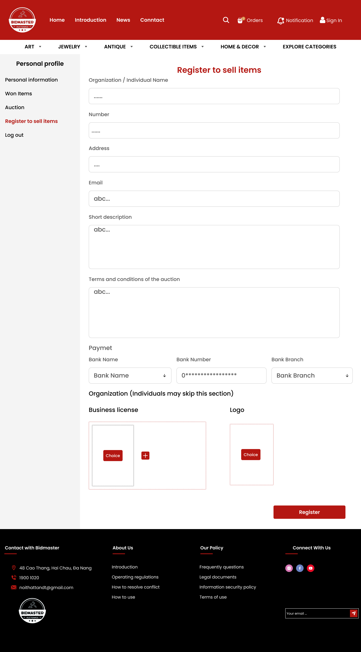

|  |  |
| --- | --- |
| **Function Diagram Name** | Register as a seller. |
| **High-Level Requirements** | Users can register to become sellers. |
| **User** | The account has a role of ‘Seller’. |
| **Description** | This function allows users to transition from customers to sellers. |
| **Activate** | NA |
| **Prerequisites** | The user has successfully registered an account. |
| **Post-processing** |  |

**Screen Content**

|  |  |  |  |
| --- | --- | --- | --- |
| **Item** | **Type** | **Data** | **Description** |
| Textbox | Textbox | Default data is empty | Includes:   * Organization / Individual Name * Number * Address * Email * Short description * Terms and conditions of the auction * Bank Number |
| Combobox | Combobox | Default data is empty | Includes:   * Bank Name * Bank Branch   Values are retrieved from the API. |
| Image | Image | Default data is empty | Upload the seller's image if it is an organization, including:   * Business license * Logo |
| Register | Button |  | Account registration successful.. |

**Action**

|  |  |  |  |
| --- | --- | --- | --- |
| **Actor** | | **System** | |
| **Main Flow: View Carts** | | | |
| 1 | On the homepage, click the user button -> click “Register to sell items” |  |  |
|  |  | 2 | The system redirects to the "Register to sell items" page. |
| 3 | Enter the required information 🡪 click the “Register” button |  |  |
| 4 |  | 4 | Check if the data has changed and is correct. |
|  |  | 4.1 | If no error occurs:   * Data has been saved to the Users table. * Display the message "Registered successfully!". |
|  |  | 4.2 | If there are errors, display the corresponding message. |

**Error Message**

|  |  |
| --- | --- |
| **Case** | **Notification Message** |
| Missing required field data. | “{Field name} is required” |

### **Seller information page**

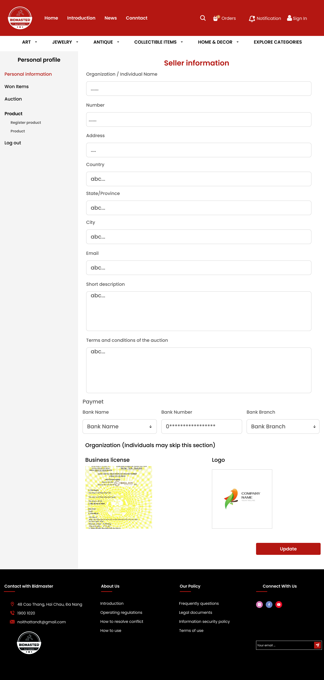

|  |  |
| --- | --- |
| **Function Diagram Name** | Update seller account information. |
| **High-Level Requirements** | Sellers can update their personal information. |
| **User** | The account has a role of ‘Seller’. |
| **Description** | This function allows sellers to update the information they have previously registered. |
| **Activate** | NA |
| **Prerequisites** | The seller has successfully registered an account. |
| **Post-processing** |  |

**Screen Content**

|  |  |  |  |
| --- | --- | --- | --- |
| **Item** | **Type** | **Data** | **Description** |
| Textbox | Textbox | Data is retrieved from User and Address | Includes:   * Organization / Individual Name * Number * Address * Country * State/Province * City * Email * Short description * Terms and conditions of the auction * Bank Number |
| Combobox | Combobox | Data is retrieved from User | Includes:   * Bank Name * Bank Branch   Values are retrieved from the API. |
| Image | Image | Data is retrieved from Media | Upload the seller's image if it is an organization, including:   * Business license * Logo |
| Register | Button |  | Account update successful. |

**Action**

|  |  |  |  |
| --- | --- | --- | --- |
| **Actor** | | **System** | |
| **Main Flow: View Carts** | | | |
| 1 | On the homepage, click the user button -> click “Seller information” |  |  |
|  |  | 2 | The system redirects to the "Seller information" page. |
| 3 | Enter the information you want to edit.🡪 click the “Update” button |  |  |
| 4 |  | 4 | Check if the data has changed and is correct. |
|  |  | 4.1 | If no error occurs:   * Data has been saved to the Users table. * Display the message "Updated successfully!". |
|  |  | 4.2 | If there are errors, display the corresponding message. |

**Error Message**

|  |  |
| --- | --- |
| **Case** | **Notification Message** |
| Missing required field data. | “{Field name} is required” |

### **Register Product page**

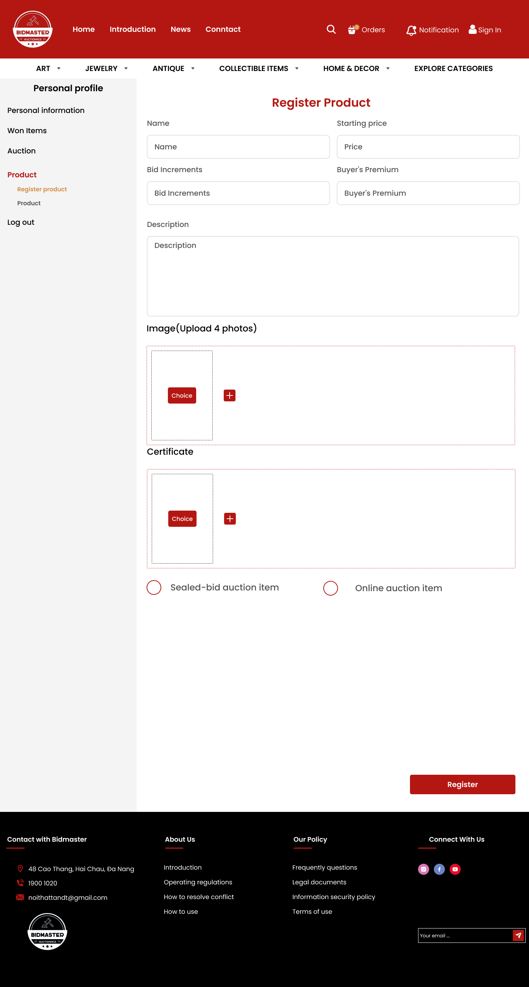

|  |  |
| --- | --- |
| **Function Diagram Name** | The seller registers to sell products. |
| **High-Level Requirements** | Sellers can register the products they want to sell on the system. |
| **User** | The account has a role of ‘Seller’. |
| **Description** | This function allows sellers to register their products on the website to organize auctions for those products. |
| **Activate** | NA |
| **Prerequisites** | The seller has successfully registered an account. |
| **Post-processing** |  |

**Screen Content**

|  |  |  |  |
| --- | --- | --- | --- |
| **Item** | **Type** | **Data** | **Description** |
| Textbox | Textbox | Default data is empty | Includes:   * Name * Starting price * Bid Increments * Buyer's Premium * Description |
| Image | Image | Default data is empty | The seller uploads images and relevant certification documents, including:   * Image(Upload 4 photos) * Certificate |
| Checkbox | Checkbox | Default data is empty | The seller selects the auction method they want to use, including:   * Sealed-bid auction item * Online auction item |
| Register | Button |  | The seller registers the product and waits for approval. |

**Action**

|  |  |  |  |
| --- | --- | --- | --- |
| **Actor** | | **System** | |
| **Main Flow: View Carts** | | | |
| 1 | On the homepage, click the user button -> click “Product” 🡪 click “Register product” |  |  |
|  |  | 2 | The system redirects to the " Register product " page. |
| 3 | Enter all required information🡪 click the “Register” button |  |  |
| 4 |  | 4 | Check if the data has changed and is correct. |
|  |  | 4.1 | If no error occurs:   * Data has been saved to the Assets table. * Display the message “Successfully registered! Please wait for review." |
|  |  | 4.2 | If there are errors, display the corresponding message. |

**Error Message**

|  |  |
| --- | --- |
| **Case** | **Notification Message** |
| Missing required field data. | “{Field name} is required” |

### **Product page**

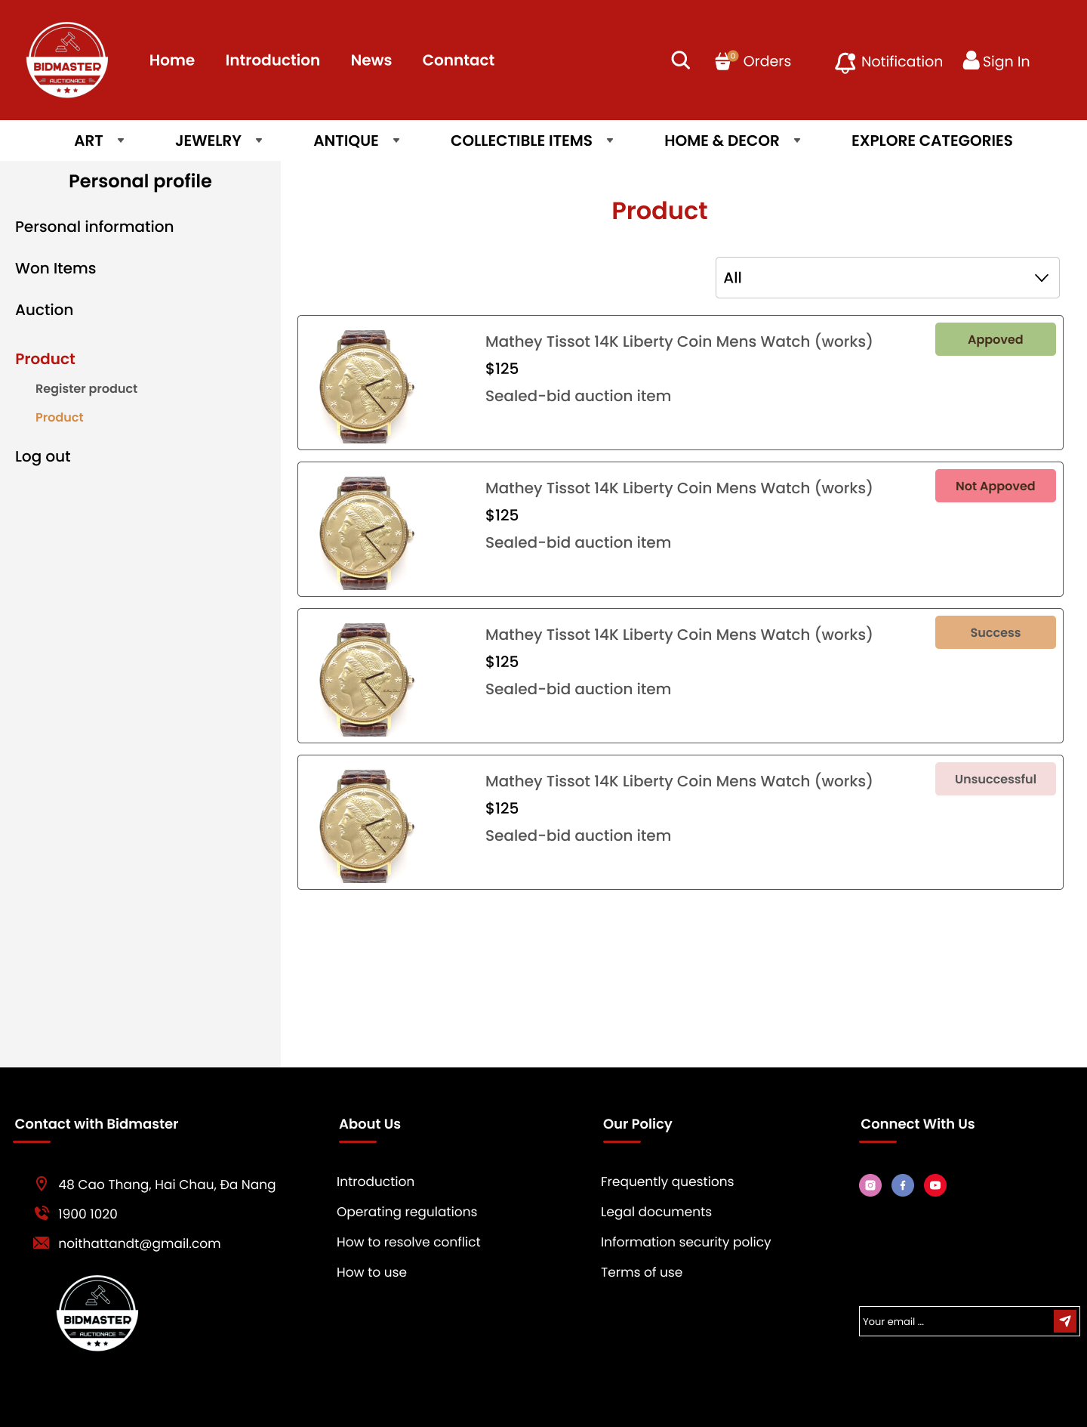

|  |  |
| --- | --- |
| **High-Level Requirements** | Sellers can view the statuses of their products. |
| **User** | The account has a role of ‘Seller’. |
| **Description** | This function allows sellers to see all the statuses of the products they have previously registered for sale. |
| **Activate** | NA |
| **Prerequisites** | The seller has registered the product. |
| **Post-processing** |  |

**Screen Content**

|  |  |  |  |
| --- | --- | --- | --- |
| **Item** | **Type** | **Data** | **Description** |
| Combobox | Combobox | Default data is “All” | Includes:   * All * Approved * Not Approved * Success * Unsuccessful |
| Image | Image | Data is retrieved from Media | Display the image of the product. |
| Price | Textfile | Data is retrieved from Assets | Display the price of the product. |
| Auction | Textfile | Data is retrieved from Auction | Display the auction method of the product. |
| Status |  |  | Display the status of the product. |

**Action**

|  |  |  |  |
| --- | --- | --- | --- |
| **Actor** | | **System** | |
| **Main Flow: View Carts** | | | |
| 1 | On the homepage, click the user button -> click “Product” 🡪 click “Product” |  |  |
|  |  | 2 | The system redirects to the " Product " page. |
| 3 | Select the status you want to view from the combobox. |  |  |
| 4 |  | 4 | The system displays the corresponding status selected by the user. |
| 5 | Click on the product you want to view details. |  |  |
|  |  | 6 | The system navigates to the "Product details" page. |

### **Product details page**

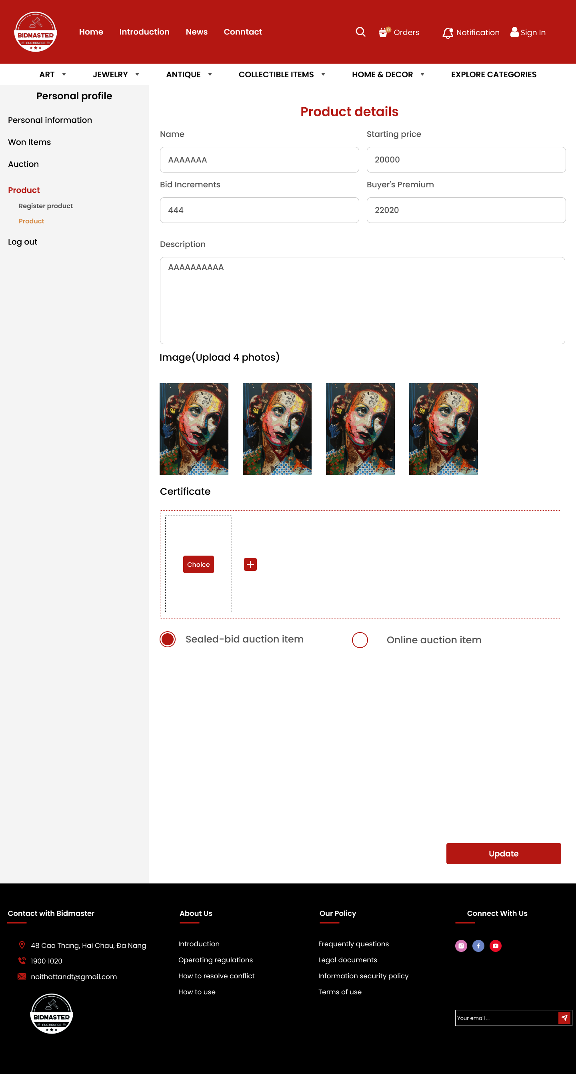

|  |  |
| --- | --- |
| **Function Diagram Name** | The seller views product details. |
| **High-Level Requirements** | The seller can view the details of their product. |
| **User** | The account has a role of ‘Seller’. |
| **Description** | This function allows the seller to view the details of the products they have previously registered for sale. |
| **Activate** | NA |
| **Prerequisites** | The seller has registered the product. |
| **Post-processing** |  |

**Screen Content**

|  |  |  |  |
| --- | --- | --- | --- |
| **Item** | **Type** | **Data** | **Description** |
| Textbox | Textbox | Display the image of the Assets | Includes:   * Name * Starting price * Bid Increments * Buyer's Premium * Description |
| Image | Image | Data is retrieved from Media | Display the image of the product. |
| Checkbox | Checkbox | Default data is empty | Display the selected auction method. |
| Update | Button |  | Update the product to the system. |

**Action**

|  |  |  |  |
| --- | --- | --- | --- |
| **Actor** | | **System** | |
| **Main Flow: View Carts** | | | |
| 1 | On the homepage, click the user button -> click “Product” 🡪 click “Product” 🡪 Select the product you want to view. |  |  |
|  |  | 2 | The system redirects to the "Product details " page. |
| 3 | Enter information into the field you want to edit. 🡪 click the “Update” button |  |  |
| 4 |  | 4 | Check if the data has changed and is correct. |
| 5 |  | 4.1 | If no error occurs:   * Data has been saved to the Assets table.   Display the message “Successfully Updated! Please wait for review." |
|  |  | 4.2 | If there are errors, display the corresponding message. |

**Error Message**

|  |  |
| --- | --- |
| **Case** | **Notification Message** |
| Missing required field data. | “{Field name} is required” |

### **Admin Statistics Screen**

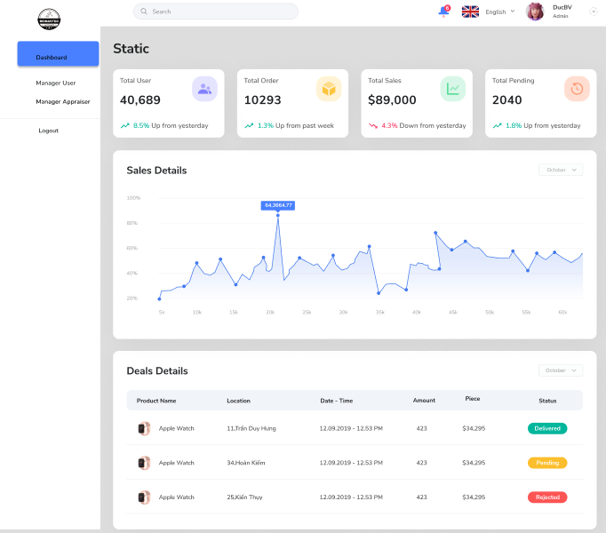

|  |  |
| --- | --- |
| **Tên sơ đồ chức năng** | Xem thống kê |
| **Yêu cầu mức cao** | Hiển thị biểu đồ, báo cáo và thống kê về các hoạt động của hệ thống |
| **Người sử dụng** | Tài khoản có quyền là “Quản trị viên” |
| **Mô tả** | Chức năng này cho phép Admin xem thông tin báo cáo và dữ liệu thống kê về hoạt động của hệ thống:  Số lượng người dùng đã đăng nhập  Số lượt truy cập  Số lượng sản phẩm được đấu giá  Số phiên đấu giá theo ngày, tháng, năm  Số lượng sản phẩm bán ra |
| **Kích hoạt** | NA |
| **Điều kiện tiên quyết** | - Quản trị viên có một tài khoản hợp lệ trong hệ thống.  - Quản trị viên đã đăng nhập thành công vào hệ thống có quyền quản trị.  - Quản trị viên có thiết bị có kết nối internet. |
| **Xử lý sau** |  |

**Hành động**

|  |  |  |  |
| --- | --- | --- | --- |
| **Actor** | | **Hệ thống** | |
| **Main Flow: Statistics** | | | |
| 1 | Actor truy cập trang Dashboard. |  |  |
|  |  | 2.1 | Hệ thống hiển thị tổng quan về tổng số sản phẩm, đấu giá, thành viên và cổ phiếu. |
|  |  | 2.2 | Nếu dữ liệu được truy xuất thành công, nó sẽ hiển thị dữ liệu tương ứng |
|  |  | 2.3 | Nếu truy xuất dữ liệu không thành công, nó sẽ hiển thị thông báo lỗi. |
| 2 | Actor xem biểu đồ doanh thu và đăng ký mới theo tuần. |  |  |
| 3 | Actor clickvào các liên kết trong điều hướng để truy cập các chức năng khác. |  |  |
|  |  | 3.1 | Hệ thống điều hướng đến trang đã chọn. |

**Nội dung màn hình**

|  |  |  |
| --- | --- | --- |
| **Mục** | **Kiểu** | **Mô tả** |
| **Header** | | |
| Menu | Menu bar | Includes:   * Static * Manager User * Manage Appraiser |
| Logout | Hyperlink | Đăng xuất hệ thống |

### **Admin screen (Management user)**

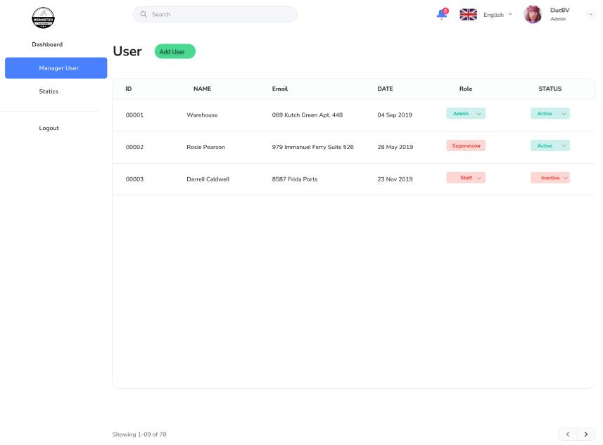

|  |  |
| --- | --- |
| **Function Diagram Name** | Show Static function (with Admin rights) |
| **High-Level Requirements** | Display list of accounts using role staff |
| **User** | Account has role ‘Admin’ |
| **Description** | This feature allows Admin to view user management information displaying a list of existing users, along with options to add new users, edit and delete users and related user information. |
| **Activate** | NA |
| **Prerequisites** | - The administrator has a valid account in the system.  - The administrator has successfully logged into the system with administrative rights.  - The administrator has a device with internet connection. |
| **Post-processing** |  |

**Screen Content**

|  |  |  |
| --- | --- | --- |
| **Mục** | **Kiểu** | **Mô tả** |
| **Header** | | |
| Menu | Menu bar | Gồm:   * Static * Manager User * Manage Appraiser |
| Logout | Hyperlink | Đăng xuất hệ thống |

### 

**Action**

|  |  |  |  |
| --- | --- | --- | --- |
| **Actor** | | **System** | |
| **Main Flow: Manage list staff** | | | |
| 1 | Chose role |  |  |
|  |  | 2.1 | Display a list of staff by role |
|  |  | 2.2 | If no records are found, display the message: “There are no employees at this location!” |
| Alternate Flow: Delete staff | | | |
| 3 | Click button delete |  |  |
|  |  | 4 | System prompts for confirmation |
|  |  |  |  |
| 5 | Admin confirms the deletion |  |  |
|  |  | 6 | System deletes the staff member details and displays a success message |
| 5 | Admin confirms the deletion |  |  |
|  |  |  |  |
| Alternate Flow: View detail staff | | | |
| 7 | Click button view |  |  |
|  |  | 8 | Display form to staff member details |

### **Staff Management_list_buyer,Seller screen**

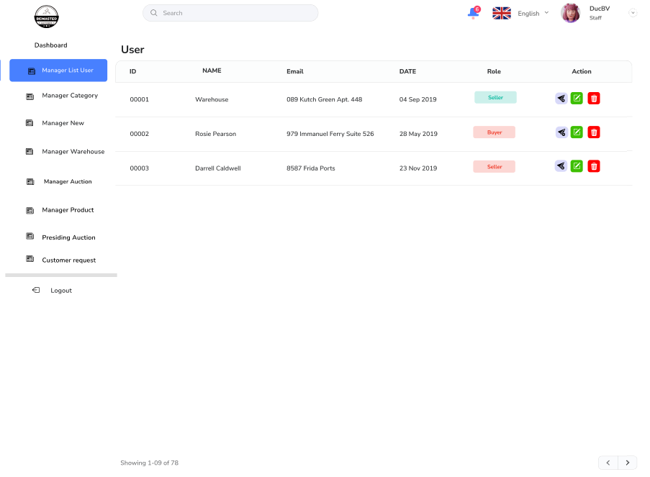

|  |  |
| --- | --- |
| **Function Diagram Name** | Show list_buyer,Seller function (Staff rights) |
| **High-Level Requirements** | Display list of buyer and seller accounts |
| **User** | Account with role ‘Staff’ |
| **Description** | This function allows Staff to be granted access to the "Buyer/Seller List" function in the Employee Management system. This function allows staff to view detailed information about buyers and sellers on the system. |
| **Activate** | NA |
| **Prerequisites** | - The administrator has a valid account in the system.  - The administrator has successfully logged into the system with administrative rights.  - The administrator has a device with internet connection. |
| **Post-processing** |  |

**Screen Content**

|  |  |  |
| --- | --- | --- |
| **Mục** | **Kiểu** | **Mô tả** |
| **Header** | | |
| Menu | Menu bar | Gồm:   * Manager List User * Dashboard * Manager Category * Manager New * Manager Warehouse * Manager Auction * Manager Product * Presiding Auction * Customer request * Logout |
| Logout | Hyperlink | Đăng xuất hệ thống |

**Action**

|  |  |  |  |
| --- | --- | --- | --- |
| **Actor** | | **System** | |
| **Main Flow: Statistics** | | | |
| 1 | Actor accesses the Accounts page. |  |  |
|  |  | 2. | The system displays a list of buyer accounts by default. |
| 2 | Actor uses the search bar to find specific accounts. |  |  |
|  |  | 3. | The system filters and displays the relevant accounts. |
| 3 | Actor clicks on the tabs to switch between buyer, seller, and staff accounts. |  |  |
|  |  | 4. | The system updates the display to show the relevant accounts. |
| 4 | Actor clicks on the status filter to view accounts with a specific status. |  |  |
|  |  | 5. | The system filters and displays the accounts based on the selected status. |
| 5 | Actor selects an account and clicks on an action button (edit, delete, view details). |  |  |
|  |  | 6. | The system performs the corresponding action. |

### **Staff Manager Auction screen**

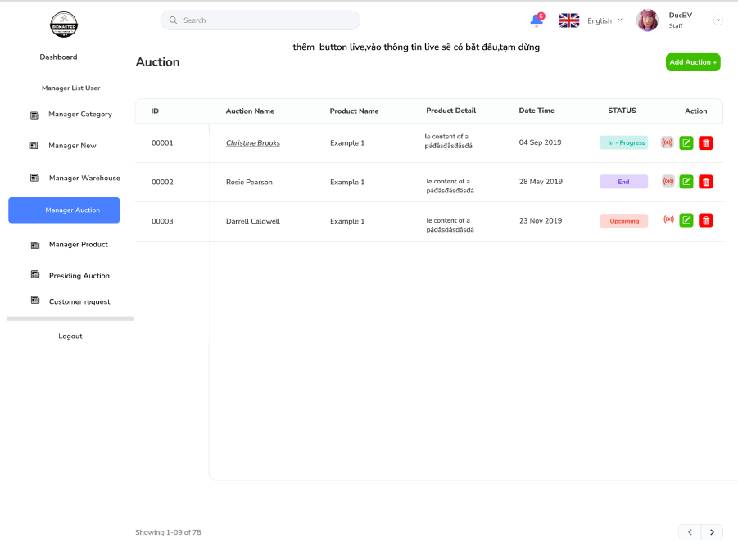

|  |  |
| --- | --- |
| **Function Diagram Name** | Show auction management function |
| **High-Level Requirements** | Show list of auctions |
| **User** | Account with role ‘Staff’ |
| **Description** | This function allows authorized Staff to access and use the "Auction Management" function in the Staff Management system. This function allows staff to view detailed information about auctions, manage the auction process and perform necessary actions. |
| **Activate** | NA |
| **Prerequisites** | - The administrator has a valid account in the system.  - The administrator has successfully logged into the system with administrative rights.  - The administrator has a device with internet connection. |
| **Post-processing** |  |

**Screen Content**

|  |  |  |
| --- | --- | --- |
| **Mục** | **Kiểu** | **Mô tả** |
| **Header** | | |
| Menu | Menu bar | Gồm:   * Manager List User * Dashboard * Manager Category * Manager New * Manager Warehouse * Manager Auction * Manager Product * Presiding Auction * Customer request * Logout |
| Logout | Hyperlink | Đăng xuất hệ thống |

### **Staff(Manager Product)**

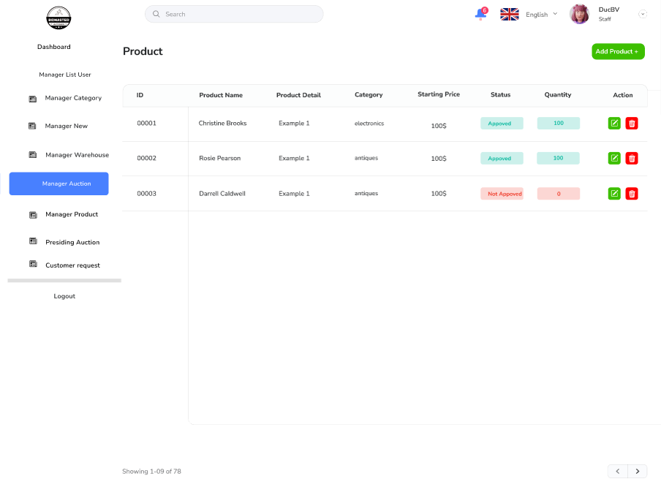

|  |  |
| --- | --- |
| **Function Diagram Name** | Show list of products |
| **High-Level Requirements** | Show product management function |
| **User** | Account có role ‘Staff’ |
| **Description** | This function allows authorized Staff to access and use the Product Management function in the Staff screen of the management system. This screen provides staff with access to functions such as managing product lists, adding new products, editing product information, deleting products, and managing product images. |
| **Activate** | NA |
| **Prerequisites** | - The administrator has a valid account in the system.  - The administrator has successfully logged into the system with administrative rights.  - The administrator has a device with internet connection. |
| **Post-processing** |  |

**Screen Content**

|  |  |  |
| --- | --- | --- |
| **Mục** | **Kiểu** | **Mô tả** |
| **Header** | | |
| Menu | Menu bar | Gồm:   * Manager List User * Dashboard * Manager Category * Manager New * Manager Warehouse * Manager Auction * Manager Product * Presiding Auction * Customer request * Logout |
| Logout | Hyperlink | Đăng xuất hệ thống |

### **Staff Manager News**

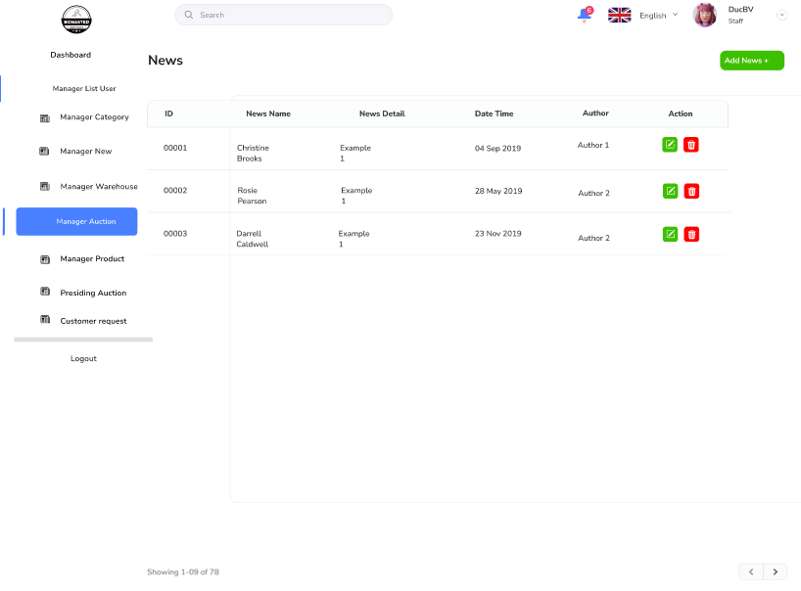

|  |  |
| --- | --- |
| **Function Diagram Name** | Show News list |
| **High-Level Requirements** | Show News management function |
| **User** | Account with role ‘Staff’ |
| **Description** | This feature allows your Staff to access and use the news management functions in the Staff (News Management) screen of the content management system (CMS). This screen provides staff with access to functions such as managing news lists, adding new news, editing news, deleting news, and managing news categories. |
| **Activate** | NA |
| **Prerequisites** | - The administrator has a valid account in the system.  - The administrator has successfully logged into the system with administrative rights.  - The administrator has a device with internet connection. |
| **Post-processing** |  |

**Screen Content**

|  |  |  |
| --- | --- | --- |
| **Mục** | **Kiểu** | **Mô tả** |
| **Header** | | |
| Menu | Menu bar | Gồm:   * Manager List User * Dashboard * Manager Category * Manager New * Manager Warehouse * Manager Auction * Manager Product * Presiding Auction * Customer request * Logout |
| Logout | Hyperlink | Đăng xuất hệ thống |

**Action**

|  |  |  |  |
| --- | --- | --- | --- |
| **Actor** | | **System** | |
| **Main Flow: Manage News** | | | |
| 1 | Chose state |  |  |
|  |  | 2.1 | Display a list of event by state |
|  |  | 2.2 | If no records are found, display the message: “There are no event at this location!” |
| Alternate Flow: Delete | | | |
| 3 | Click button delete |  |  |
|  |  | 4 | System prompts for confirmation |
| 5 | Admin confirms the deletion |  |  |
|  |  | 6 | System deletes the event details and displays a success message |
| Alternate Flow: edit | | | |
| 7 | Click button edit |  |  |
|  |  | 8 | Display form to edit event details |
| Alternate Flow: add | | | |
| 9 | Click button add |  |  |
|  |  | 10 | Display form to add event details |

### **Staff Asset auction inspection**

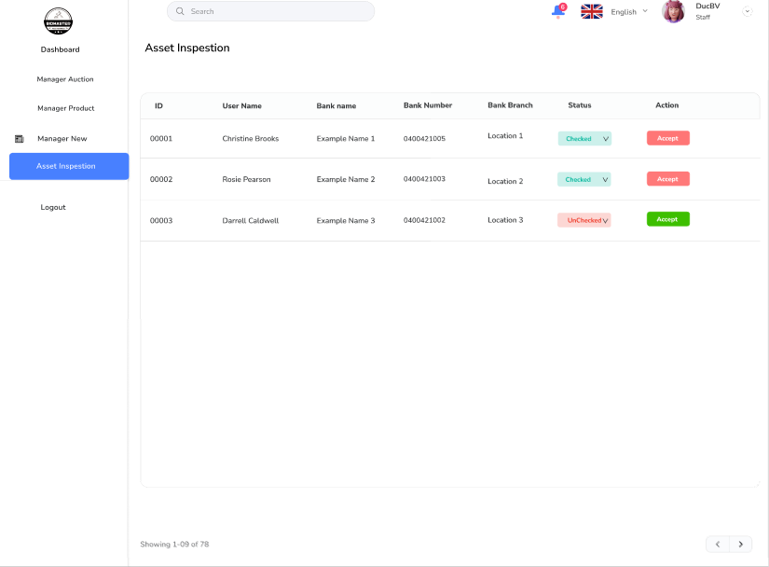

|  |  |
| --- | --- |
| **Function Diagram Name** | Display list of property inspectors |
| **High-Level Requirements** | Show auction property check function |
| **User** | Account có role ‘Supervison’ |
| **Description** | This function allows Staff to access and use the asset auction checking functions in the Staff (Asset Auction Check) screen of the auction management system. This screen provides staff access to functions such as viewing detailed information about the auctioned assets, approving/rejecting assets, managing auction records, and tracking the auction process.  Approve asset: allow the asset to participate in the auction.  Reject asset: refuse to participate in the auction for a specific reason.  Request additional documents: request the seller to provide additional documents related to the asset property.  Send message to seller: exchange information with seller about property status.  View inspection history: review previous notes and decisions of other inspectors (if any).  Only authorized staff can access and use the property auction inspection functions.  Staff must comply with the property evaluation criteria specified by the system.  The decision to approve or reject a property must be based on legality |
| **Activate** | NA |
| **Prerequisites** | - The administrator has a valid account in the system.  - The administrator has successfully logged into the system with administrative rights.  - The administrator has a device with internet connection. |
| **Post-processing** |  |

**Screen Content**

|  |  |  |
| --- | --- | --- |
| **Mục** | **Kiểu** | **Mô tả** |
| **Header** | | |
| Menu | Menu bar | Gồm:   * Manager List User * Dashboard * Manager Category * Manager New * Manager Warehouse * Manager Auction * Manager Product * Presiding Auction * Customer request * Logout |
| Logout | Hyperlink | Đăng xuất hệ thống |

### **Supervision Asset auction inspestion**

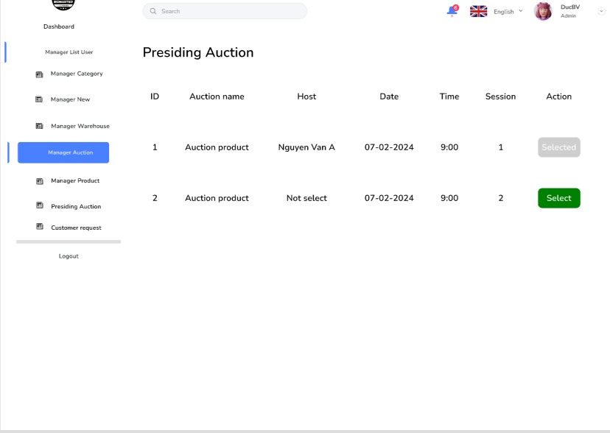

|  |  |
| --- | --- |
| **Function Diagram Name** | Display list of auctions, select auction host |
| **High-Level Requirements** | Show auction host function |
| **User** | Account có role ‘Staff’ |
| **Description** | This function allows Staff to access and use auction management functions in the Staff (Auction Management) screen of the auction management system. This screen provides staff access to functions such as tracking the auction process, managing participants, handling disputes, and closing auctions.  The staff has been trained in the auction management process.  The auction is about to take place or is in progress.  The staff can manage auction participants.  Remove invalid participants from the auction.  Prevent participants with a history of cheating.  The staff can handle disputes between auction participants.  Receive and review complaints from participants participants.  Make a decision to resolve a dispute based on the system's rules.  Staff can end the auction.  Check if any participants are placing bids in the final seconds.  Determine the winner as the highest bidder. |
| **Activate** | NA |
| **Prerequisites** | - The administrator has a valid account in the system.  - The administrator has successfully logged into the system with administrative rights.  - The administrator has a device with internet connection. |
| **Post-processing** |  |

**Screen Content**

|  |  |  |
| --- | --- | --- |
| **Mục** | **Kiểu** | **Mô tả** |
| **Header** | | |
| Menu | Menu bar | Gồm:   * Manager List User * Dashboard * Manager Category * Manager New * Manager Warehouse * Manager Auction * Manager Product * Presiding Auction * Customer request * Logout |
| Logout | Hyperlink | Đăng xuất hệ thống |

### **Staff Warehouse Management**

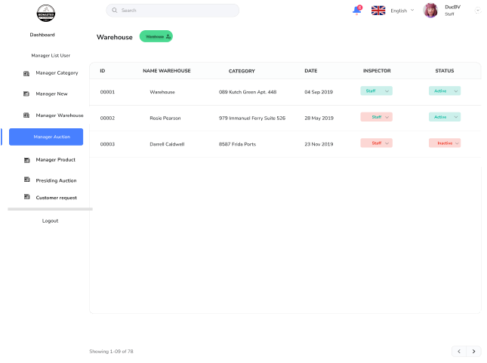

|  |  |
| --- | --- |
| **Function Diagram Name** | Display list of warehouses and quantity of goods |
| **High-Level Requirements** | Show warehouse management function |
| **User** | Account có role ‘Staff’ |
| **Description** | This functionality allows your Staff to have access to functions such as managing inventory lists, tracking inventory status, processing orders, managing warehouse staff, and tracking inventory reports. |
| **Activate** | NA |
| **Prerequisites** | Authorized staff have a valid account in the system.  Staff have a device with internet connection.  Staff have been trained in warehouse management procedures and use of the system.  Staff can add new goods to the warehouse.  Enter detailed information about goods (name, code, description, supplier, quantity, price).  Assign barcodes to products (if any).  Locate goods in the warehouse.  Staff can update information about existing goods.  Information that can be updated includes inventory quantity, price, expiry date, supplier information.  Staff can track import and export history Detailed information about imported goods (from which supplier, how much) and exported goods (for which order, how much). |
| **Post-processing** |  |

**Screen Content**

|  |  |  |
| --- | --- | --- |
| **Mục** | **Kiểu** | **Mô tả** |
| **Header** | | |
| Menu | Menu bar | Gồm:   * Manager List User * Dashboard * Manager Category * Manager New * Manager Warehouse * Manager Auction * Manager Product * Presiding Auction * Customer request * Logout |
| Logout | Hyperlink | Đăng xuất hệ thống |

## 

## **V. Convention**

### **Textbox**

* Default value is blank if SRS has not defined default value

### **Grid**

* Display all records from the DB as default
* When click on column header then sort data
* The even and odd rows have different colors

### **Combo-box**

* Default value for combo box is blank item if SRS has not defined default value
* Combo boxes content must be sorted alphabetically unless specifically stated in the SRS
* The required combobox on Create/Edit screen must not include the blank item
* The optional combobox on Create/Edit screen must include the blank item

### **Date picker**

* Format is DD/MM/YYYY
* Allow to input a valid date only or select a date from Calendar

### **Message**

* The error message should be a red inline message and displayed under the corresponding field.
* The successful message should be a green toast message at the top-right of the screen.
* The message notified that no record found should be a red inline message and displayed under the grid.
* The confirmation message for Delete/Reject/Approve function should be a popup and No button is set focus

### **Search function**

* When user input data into textbox, system will search for containing that data
* When user input/select data into/from other controls, system will search for exactly that data
* When user search by multiple conditions, system will display all records that satisfy all entered conditions
* Search screen has Reset button to reset all search criteria input control to default value
* Blank text boxes or blank date pickers or ‘(All)’ combobox or checked ‘(All)’ checkbox list means do not consider the criteria. Thus do not include the criteria in the WHERE clause.

### **Paging section**

* Display 10 records/page.
* 4 icon buttons: First (Tooltip: ‘First Page’), Previous (Tooltip: ‘Previous Page’), Next (Tooltip: ‘Next Page’), Last (Tooltip: ‘Last Page’)
* When system displays all records at first page, system must be disable First and Previous buttons.
* When system displays all records at last page, system must be disable Last and Next buttons.
* Page textbox will be editable and show the current page
* Label “Of n” will show total of pages (n = total of records found / number of records per page)
* When no record found in grid, Page textbox is ‘1’ and n is 1
* When user enter a number into the Page textbox and pressing Enter, system displays all records of the desired page
* When user click on the First Page icon button, system displays all records of the 1st page on the grid
* When user click on the Previous Page icon button, system displays all records of the previous page on the grid
* When user click on the Next Page icon button, system displays all records of the next page on the grid
* When user click on the Last Page icon button, system displays all records of the last page on the grid

### **Add/Edit/Delete an item at Search screen**

* After adding/editing a record at the search screen
  + The popup must be closed
  + The system must refresh the search page
* After removing an item from the search screen, that item must be also removed from the search result list.

### **Checkbox list**

* Values must be sorted alphabetically unless specifically stated in the SRS

### **Checkbox**

* Default value is unchecked if SRS has not defined default value

### **Textarea**

* Default value is blank if SRS has not defined default value